PEMBROKE TOWN COUNCIL

ANNUAL REPORT 2024 - 2025

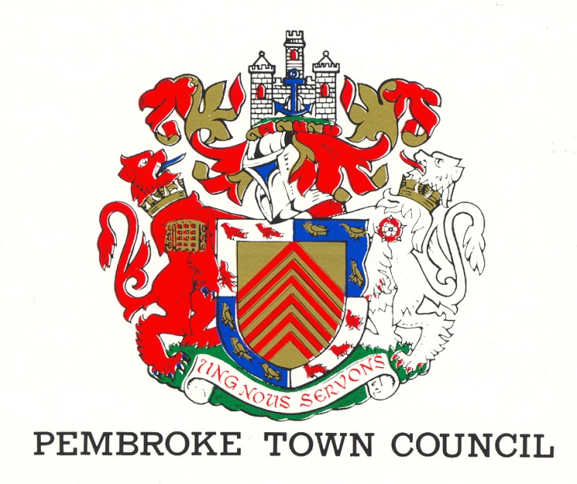
REV 4 (June 2025)
The Town Hall
Main Street
Pembroke
SA71 4JS
Tel: 01646 683092
Email: enquiries@pembroketowncouncil.co.uk
Website: www.pembroketownguide.co.uk

INTRODUCTION:
This Annual Report provides an update on our services and achievements over the last year and to see how the Council has grown and developed to meet the needs of the community.
We are required by legislation under the Local Government and Elections (Wales) Act 2021 to prepare an Annual Report. This report is also a requirement of the Well Being of Future Generations (Wales) Act 2015 and of the Environment (Wales) Act 2016.
This report will update the public, the auditor, and the Welsh Government on how we are making a difference in the town, how we are delivering against our Wellbeing Goals and on environmental issues.
The Cost of living is still affecting business owners in the Main Street but luckily have managed to avoid closure. Still waiting news from Pembrokeshire County Council, in their award of 10.3 million for Pembroke (which was delayed due to the change of government) and are keen to work closely with them, which has been emphasised in various meetings held.

PEMBROKE TOWN COUNCIL:
The Council is made up of fifteen (15) councillors elected by the residents of Pembroke and the Council employs five (5) members of staff.
- Town Clerk
- Deputy Town Clerk
- Two cleaners / Caretakers
- Handyman

The gender makeup of staff and councillors can be seen below.
STAFF: COUNCILLORS:
5 15
60% female 40% female
40% male 60% male
We have four (4) County Councillors representing the four Pembroke Wards
1 Female 25% 3 Male 75%

Just recently we have had a resignation of a Councillor, which is currently being advertised for co-option (as no 10 residents have called for an election) for the Monkton Ward.

NAME | CONTACT DETAILS
St Mary’s South Ward
Herring, Lee | 4 Moat House Cottages, Commons Road, Pembroke, SA71 4EB  07526 756620 Cllr.lee.herring@gmail.com
Jones, Gareth | Picton House, 59 Main Street, Pembroke, SA71 4DA  07973382144 pictonhouse@aol.com
Nicholas, Keith | Corner House, 1 Gibbas Way, Pembroke, SA71 5JA  01646 621374/07879337032 kkinssvs@aol.com
Willcocks, Deborah | 4 Merchants Park, Pembroke, SA71 4HD  07816 454678 Deborah.grimes@sky.com
St Mary’s North Ward
Asman, Linda | 28 Rocky Park, Pembroke, SA71 4NY  07584429224  linda.asman@hotmail.com
Blackburn, Rose | 13 Buttermilk Close, Pembroke, SA71 4TN  01646 681362 postmaster@rosecuts.plus.com
Bush, Daphne | Holybush Cottage, 7 Golden Brake, Pembroke, SA71 4BU  01646 681437 daphne_bush@hotmail.com
Mortenson, Ann | Charm Cottage, Lower Row, Golden Hill, Pembroke, SA71 4TG  07807129963 annmortenson@yahoo.co.uk
Monkton Ward
Cooke, Adrian | The Mews, 31 Main Street, Pembroke, SA71 4JS  07592485589 adriancooke660@gmail.com
Grimes, Jonathan | 4 Merchants Park, Pembroke, SA71 4HD  07827999448 jonathan@justgreatdesign.co.uk
Jenkins, Liz | Priory Farm, Church Terrace, Monkton, Pembroke, SA71 4LW  01646 684277 lizjenkins183@gmail.com
St Michael’s Ward
Brinn, Aden | The Garden Flat, 33 Pembroke Street, Pembroke Dock, SA72 6HX  01646 622703/07891902426 adenbrinn@aol.com
Collins, Clive | 5 Vicarage Fields, Pembroke, SA71 4AQ  01646 681500 cbros1939@gmail.com
Evans, Dennis | 17 Michael’s Road, Pembroke, SA71 5JQ  01646 683615 dw.evans939@btinternet.com
Willington, Darrell | 18 Upper Lamphey Road, Pembroke, SA71 5JL  07966182122 willers_machen@yahoo.co.uk

Register of Attendance of Ordinary Meetings of Pembroke Town Council
2024/25 | 09-May | 13-Jun | 11-Jul | no meeting | 05-Sep | 03-Oct | 07-Nov | 05-Dec | 16-Jan | 13-Feb | 13-Mar | 17-Apr
Jones G H | ü | ü | ü | NM | ü | ü | ü | ü | ü | ü | ü | ü | 100%
Nicholas KN | ü | ü | A | NM | A | ü | ü | ü | A | ü | ü | ü | 73%
Asman L | ü | ü | ü | NM | A | ü | ü | ü | ü | ü | ü | A | 82%
Blackburn R | ü | ü | ü | NM | ü | ü | ü | ü | ü | ü | ü | ü | 100%
Bush D | ü | A | A | NM | ü | A | A | left early | arrived late | arrived late | ü | ü | 64%
Mortenson A | ü | ü | ü | NM | ü | ü | ü | ü | ü | ü | A | A | 82%
Cooke A | ü | ü | ü | NM | A | ü | ü | A | A | A | Resigned |  | 45%
Grimes J | ü | ü | ü | NM | ü | ü | ü | ü | ü | ü | ü | ü | 100%
Jenkins L | ü | ü | A | NM | ü | ü | ü | ü | ü | ü | ü | A | 82%
Brinn A | ü | A | ü | NM | A | ü | A | ü | A | (A - ILL) | ü | ü | 54%
Collins C | A | A | ü | NM | ü | ü | ü | A | A | A | ü | ü | 54%
Evans D | ü | A | ü | NM | ü | ü | ü | ü | ü | ü | ü | ü | 91%
Willington D | A | A | ü | NM | A | ü | ü | A | ü | ü | ü | ü | 64%
D Wilcox | ü | ü | ü | NM | ü | ü | ü | ü | ü | ü | ü | A | 91%
L Herring | ü | ü | ü | NM | ü | ü | ü | ü | ü | ü | ü | ü | 100%
Total
Suzie Thomas | ü | ü | ü | NM | ü | ü | ü | A | ü | ü | ü | ü | 91%
Jayne Howes | ü | ü | ü | NM | ü | ü | ü | ü | ü | ü | A | A | 82%

WHAT DO WE DO?
The activities of the Council can be broken down into three areas –
- Town
- Finance
- The Community

TOWN:
- We manage the office of the Mayor and Deputy Mayor of the town
- We rent out facilities within the Town Hall enabling groups such as the Pilates and the Craft and Food markets to trade
- We work with PCC on the GI (Green Infrastructure) project
- We work with the Showmen’s Guild and assist in the annual Michaelmas Fair
- We liaise with the Dyfed Powys Community Police Team and the Pembroke Street Pastors
- We work alongside Pembrokeshire County Council in the Regeneration of Pembroke
- Liaise with Transport for Wales and participate in the Train Adopter Scheme
FINANCE:
- We fund the Christmas lights and flowers within the town
- We pay 50% of the running costs to ensure that our library is kept open for the use of the community
- We fund the operating costs to ensure that the public toilets at East End are open for the use of our residents and visitors
- We finance the cost of council elections
- We provide funding to small groups within the town
- We pay for the inspection of our Play Parks
- We pay yearly to remove the algae from the Mill Pond and cut down the reeds
COMMUNITY:
- We deliver community events such as the River Rally and the Father Christmas Sleigh run
- We provide Community Governors to the two primary schools and the secondary school
- We represent the community on a number of outside agencies and companies e.g. Valero Refinery, Pembroke Power Station
- We provide a litter picking service
- We hold an annual awards evening to honour the work and dedication of residents within the town
- We house the museum in our Court room as a community facility
- Organise the Freshwater West Landing Disaster Service annually to remember those who lost their lives
- Support Ironman by opening the Town Hall and offering local charities/churches to provide refreshments for spectators and providing a compere to support the athletes taking part
- In conjunction with Pembroke Dock Town Council hold an annual Armed Forces Day
- We support the following groups and organisations within the town-
- Tanyard Youth Club
- Foundry House Community Centre
- Town Walls Trust
- Civic Trust
- Chamber of Trade
- The Freeman’s Gild of Pembroke
- Pembroke Young at Heart Group
- British Legion – Remembrance Service
- Pembroke Museum
(10) Pembroke & Monkton History Society

MAYORS TERM OF OFFICE – COUNCILLOR ANN MORTENSON
Community Engagement and Celebrations
From the outset, I embraced every opportunity to celebrate our town and its people. A highlight was welcoming the annual Classic Car Show to Pembroke. Meeting the passionate drivers and hearing the stories behind their vehicles deepened my appreciation for the history and camaraderie the event brings each year.

I had the pleasure of attending Mayoral Civic Services across Pembrokeshire, where I connected with Councillors from other communities, gaining insight into what makes our County so special. I also met the leader of Pembrokeshire County Council, and dedicated MPs and MSs, all working tirelessly for the good of our community. But the most charming of my escorts was undoubtedly my granddaughter Arianwen, who won hearts wherever we went.

Cultural and Civic Contributions
Pembroke Festival Week was a vibrant success thanks to the efforts of the Pembroke Town Team. It was a joy to help open many of the events that showcased our town’s culture and spirit.

In June, I attended the VC Gallery Awards Ceremony, which left a lasting impression on me. Inspired by their work, I began volunteering with them weekly – a decision that has enriched my life immensely.

Other special moments included: The Young at Heart VE Day Dinner and lighting the beacon at Pembroke Castle; the Hundelton WI coffee morning; the RNLI reception at Pembroke Castle; the Lamphey Scouts AGM; the MPHA Summer Reception; and representing Pembroke at Armed Forces Day in Pembroke Dock

Faith and Heritage
As a devout Christian, it has been deeply meaningful to attend several services at St Davids Cathedral in my Mayoral role. One of the most personal highlights was the honour of attending the licensing of Rev Hannah Karpati at the Church of St Mary in Carew, where I was invited especially by Hannah herself.
Sailing the Pembroke River to herald the River Rally was an adventure I won’t soon forget – made all the more enjoyable by our skilled skipper.
The historic Michaelmas Fair brought back memories of when my own children were young, and it was a delight to share it this year with my grandchildren.

Moments of Reflection and Festivity
Remembrance in November was particularly moving. Listening to stories of sacrifice and loss within our community reminded me how important it is to keep these memories alive through prayer and reflection.

The came Christmas – the busiest and most joyful time of the year: Opening the famous Pembroke Castle Christmas Market; leading the Pembroke Lantern Parade; singing carols at the Young at Heart Christmas Dinner; visiting care homes; and helping Santa on his sleigh.

I was especially proud that my granddaughter designed the official Pembroke Town Council Christmas card, raising £257 for Mind.

New Year, New Traditions
With the turn of the year, I focused on launching the St David’s Day Parade, which was a tremendous success, drawing both locals and tourists. I am thrilled that the Welsh Guards are keen to return for the Ceremony of the Leeks in 2027. Their concert at Ysgol Harri Tudur was a true highlight.
To close my Mayoral year, I ticked off a major item from my bucket list: camping overnight in Pembroke Castle. It was every bit as magical as I had hoped.

Overcoming Challenges
As someone living with dyslexia and hearing difficulties, I initially found public speaking daunting. But with the unwavering support of my Church community, I found confidence and courage. I am also grateful to Disability Confident for providing tools and resources that made a real difference in making my duties more accessible.

Looking Ahead
Though my term as Mayor comes to a close, my dedication to our community does not. I will continue to offer my support wherever I can. I extend heartfelt tanks to all Town Councillors and Town Council staff for their support, and a special mention to Lynn Edwards, who graciously served as Lay Preacher during my tenure.

Thank you, Pembroke, for giving me the honour of serving you.
Warmest Regards
Cllr Ann Mortenson
Mayor of Pembroke 2024-2025

WELLBEING GOALS FOR PEMBROKE
Again, this year, we have had to invest heavily into the Town Hall, by replacing the rear roof, painting of the front of the Town Hall, and Council Chamber and restoration of the external windows. We also invested in the installation of storage cupboards, due to the deterioration of the metal cabinets that were there previously, this freeing up more space in the Meeting Room, improving the facilities to rent out. We have updated with partial funding from Pembroke Young at Heart, with the purchase of new chairs for the Main Hall. We have had to put a slight increase of the prices for the letting of the Town Hall, due to the cost of utilities, however bookings are still very positive with increased income from last year.
Still working with Keep Wales Tidy, we have seen another increase this year, on the public borrowing litter picking equipment, with schools and organisations such as cubs/scouts etc
In this financial year, we have taken ownership of a piece of land from Pembrokeshire County Council and turned into a Community Growing Area. This has proved very successful, with a large uptake taken up as soon as it was advertised. With the help of Pembrokeshire Couty Council, we were able to secure a grant, aiding us to install a gravelled path throughout the field, and clear the overgrown site for preparation of the new gardeners.
The office of the Town Hall, still organize the Young at Heart Trips, which take residents of Pembroke who are over the age of 55 out for the day, and also arrange dinners (with the help of a Committee) at the Town Hall, for certain events, i.e. Harvest, Christmas and this year we did a luncheon to mark the 80th Anniversary of the D Day Landings, and also marked this occasion with the lighting of the Beacon in Pembroke Castle.
This year we had a very successful River Rally, even though limited by space on the South Quay due to the ongoing building works. We ran a children’s fancy dress competition and supplied free gift boxes (pirate themed) which was welcomed by everyone. We also organized a Treasure Hunt, and had entertainers on site including a Magician, Face Painter and local Charity Stalls. A local children’s dance group “Vibe” entertained the crowds, before the flotilla of boats arrived into the Castle Pond.
The Town Council decided due to the increase in footfall into the Town Hall to employ a seasonal receptionist, who was with us for 3 months of the Summer Season. Rachel also designed two new leaflets which encouraged visitors and locals to walk our very impressive Mill & Castle Ponds, which included one especially designed for children.
The Town Council invested into a contract to supply new Christmas Lights this year, with also an added laser beam, which was projected onto the Westgate Chapel, which again proved very popular with the local residents.
Here is a selection of Concerns raised by the pubic, and what Councillors have achieved in the last 12 months:
Councillor Linda Asman

There have been 2 major things I have been involved in this past year - opposition to the South Quay plans and Pembroke Museum.
Planning
Pembroke Town Council is required to comment on planning applications and to put forward objections when it considers plans to be detrimental to Pembroke.
There was considerable opposition to Phase 2 of the South Quay development, ie a social services hub, as Council considers the plans to be totally inappropriate for such a sensitive site in the heart of the Pembroke Conservation Area. The proposed, unsympathetic and extremely large modern building would completely dominate the South Quay and seriously impinge on the listed setting of the Castle and Church, whilst overpowering the Royal George and 7 Northgate Street.
Council’s valid objections to PCC’s Planning Committee, argued by myself on Council’s behalf along with County Cllr Jonathan Grimes and Peter Thomas of the Pembroke Civic Trust were, however, overruled.
It was made clear that, whilst PTC would welcome the Social Services Hub, it could not agree to support it on the South Quay, pointing out that the perfect site would be Riverside, a building in the ownership of PCC and now standing empty. Here there was space, good safe access, lovely grounds, peace and lots of space to develop apartments for the elderly and disable who would be able to enjoy the facilities open to them in such a development. It was in the heart of a wider community, which would be able to avail themselves of communal facilities and involvement as the former Friends of Riverside had done.

Pembroke Museum
I am pleased to report that Pembroke Museum has been awarded full accreditation status by the Welsh Government. To qualify for the award, museums must meet standards on how they are managed, on the services they offer and how they manage their collections.

The museum originated as a project of Pembroke Town Council’s Regeneration Committee, which was set up in 2013 to undertake projects to enhance the town, and Pembroke & Monkton Local History Society (to which I am Chairman) was asked if it could undertake the task of organising a museum in the old magistrate’s court.
What began as a local history exhibition of display boards of photographs and stories soon attracted donations of artefacts and, thanks to generous community donations, the Society has been able to develop some very interesting and important collections relevant to the history of our town.

Thanks to our hard work with our dedicated volunteers, we have now met nationally agreed standards for UK museums and that it is recognised at the same level as Wales’ larger and professionally staffed museums. This is no small achievement for a museum entirely run by volunteers.

Pembroke Museum is a great example of a community project which has enabled the Council to provide an important service to the town.

Councillor Rose Blackburn
I have assisted Buttermilk Residents in Pembroke North to get parking restrictions. I also have supported the Pembroke Museum in various ways and also the Pembroke & Monkton History Society. Interceded with County Council on behalf of residents in Pembroke North.
Councillor Aden Brinn
During the last 12 months my role as a Town Councillor for Pembroke St Michael Ward have been to be made available and to listen to the concerns of my electorate and give advice on the various issues which face our residents, and which have been addressed to me in this role of a Town Councillor. Incidentally, I have been contacted mostly by email and telephone. We, Pembroke Town Council collectively work for the interests of our Community of this Ancient & Historic Town of Pembroke serving our Townspeople.
Councillor Daphne Bush
Councillor Clive Collins
As per the last 25 years, I help drive Santa on his Sleigh around the streets of Pembroke and Monkton. I attend committees to represent Council at the quarterly meetings for Valero and RWE and have recently (after 20 years) have handed my notice in as a Governor for Lamphey school. I am a Trustee of Pembroke Castle, and also President of the Pembroke & District Male Voice Choir.
Councillor Dennis Evans
During the year I have been able to assist the residents of St Michaels Ward and in particular during the last few weeks when the stray ponies have been grazing on the gardens and playing fields of the residents. In addition, I have tried to ensure that the mandatory council documents, for example Standing Orders have been updated on a regular basis and that our Financial Risk Assessment Policy contains the relevant changes agreed by Council.

Councillor (County) Jonathan Grimes
As a Town Councillor for Monkton, I have taken part in various activities, including supporting the PCC Housing Road show as well as accompanying PCC housing wardens on regular basis to visit clients.
As well as this, I take part in joint patrols around the ward with the Pembroke and Pembroke Dock Neighbourhood Policing and Protection Team and have attended several Dyfed-Powys Police events including "Cuppa with a Copper" at Dezza's Cabin in Monkton.
I been involved in supporting residents with concerns over the fly-grazing of horses and have liaised with both the police and county council.
I take part in regular litter-picking across Monkton and also use this time to meet with residents to discuss any issues.
Regeneration of Pembroke has continued to be high on my list of priorities and I have supported the Town Council at various regeneration meetings as well as at County Council.
I continue to be a Governor at Monkton Priory School and a Trustee at the Tanyard Youth Group.
In 2025/26 I look forward to becoming Deputy Mayor of Pembroke and will do I can to assist the Mayor in the successful running of the Town Council.
Councillor Lee Herring
This past year. I have worked actively to fulfil my responsibilities as a Town Councillor for St Mary South, both within the Council Chamber and out in the community.
I have attended and participated in every Ordinary Meeting of the Council, ensuring that I am present for key discussions and decisions affecting our town. I current serve on several committees where I will continue to increase my involvement in ongoing projects and discussions that support local interests and initiatives.
Outside of formal meetings, I have been committed to community engagement. I regularly distribute newsletters to keep residents informed about events and issues impacting the ward. I also conduct regular ward walks to stay visible and accessible, listen to concerns, and identify local matters first-hand. This has included reporting potholes, anti-social conduct, fly-grazing, liaising on street signage issues, and responding promptly to resident enquiries via telephone and email.
In addition to these duties, I have taken a ceremonial/civic responsibility. As a Mace Bearer to Pembroke, I was honoured to accompany the Mayor of Pembroke during the Opening of Pembroke Michaelmas Fair 2024, and I am scheduled to attend the Lighting of the Beacon, and the Mayor Making ceremony 2025 in the same role.
I have also expanded my community involvement by becoming a Trustee and Secretary to Foundry House Community Centre, and an Additional Community School Governor for Golden Grove, where I aim to continue supporting local education and community access to services.
I am proud to serve the residents of St Mary South, and I remain committed to continuing to drive positive change, champion local needs, and represent our community with integrity and dedication.
Councillor Liz Jenkins
Pembroke Town Councillors have been working together to achieve the best outcomes for the town and its residents. On occasions this has meant us challenging the County Council if we do not agree with their proposals. We have approached this in a professional manner to develop a mutual respect, but with a determination to be consulted in any future development.
Locally, I have supported/signposted residents with problems such as anti-social behaviour, planning, straying horses, maintenance etc.
Councillor Gareth Jones
I continue to work with the Town Council, neighbouring communities, and the Royal British Legion to deliver remembrance events.
This year, I have served as the Deputy Mayor and I have supported the Mayor in delivering her duties and stepped in as required when Cllr Mortenson has been unavailable or already committed to events elsewhere.
As Town Crier, I promote events and causes within the Community of Pembroke, announcing ceremonies and activities and "Heralding" the attendance of the Mayor. Other duties involve Supporting Santa's Sleigh through Pembroke and Monkton - and making sure that Santa turns up !

This year, I have stepped into the role of Town Council Link with the Pembroke Street Pastors and I look forward to supporting these volunteers and their selfless efforts on behalf of those needing assistance, comfort or just a smile. Thank you Pembroke Street Pastors.

I also Chair the Pembroke Young at Heart Committee delivering Trips, events, and company throughout the year.

Councillor Keith Nicholas
Over the last 12 months it has been a pleasure being a member of Pembroke Town Council.
I have enjoyed listening to views and concerns from people and passed these comments to Pembroke Town Council or other relevant bodies.
I look forward to continuing with my roll of councillor in the future.
Councillor Deborah Willcocks
During the last 12 months as Councillor, I have helped out with the following events:
1. Attended and laid a wreath on Remembrance Sunday.
2. Assisted at the Christmas event at Pembroke Castle, handing out selection boxes.
3.Assisted at The Welsh Guards band event at Pembroke School.
4.Have been litter picking.
5. Liaised with and supported my local County Councillor.

Councillor Darrell Willington
I regularly walk around the ward and occasionally attend Pembroke RFC weekly coffee mornings, which allows residents to refer and discuss any issues of concern. I have referred a number of issues to Mel Phillips our ward County Councillor.
Speeding on our roads is a constant issue, we have seen infrequent speed checks being carried out, but it's a constant and persisting problem, given the restrictions imposed by Welsh Government last year.
I also reported lack of parity of availability and use of the Harri Tudor 3G pitch for rugby clubs, as football monopolises this facility; PCC coordinators are ambivalent and do nothing re this problem.
Other things reported include state of roadside gutters, which are clogged with litter and plant growth, meaning they are totally ineffective and so increase issues at times of heavy rain.
The pernicious problem of FLY GRAZING by traveller horses and ponies, which has impacted on residents properties, sports fields and on our busy roads.
Need for road markings to help control traffic movements and reduce hazards on a busy, local housing estate.
Issues around road hazards for older people.
I am aware of residents comments re current developments in our town and try to answer any queries they have in line with Council policy and decision.

References:
Local Government and Elections (Wales) Act 2021
Wellbeing of Future Generations (Wales) Act 2015
Environment (Wales) Act 2016
Pembroke Town Council – Wellbeing and Future Generations Policy 2021
Pembroke Town Council – Standing Orders
Pembroke Town Council – Welsh Language Policy

A Year in Pictures of Pembroke Town Council
Pembroke Michaelmas Fair
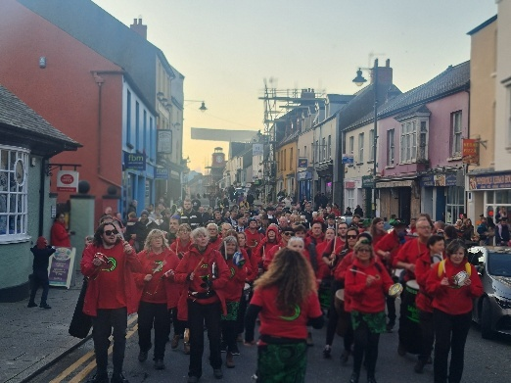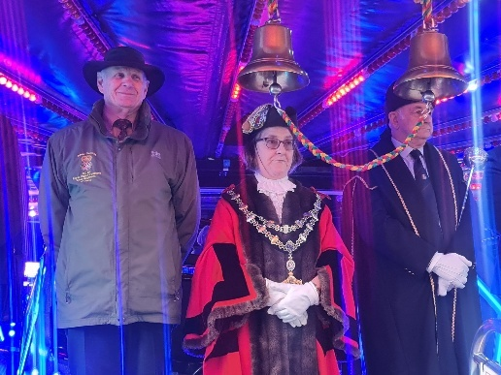

Pembroke River Rally
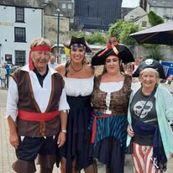 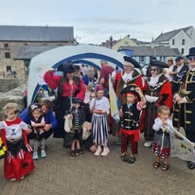

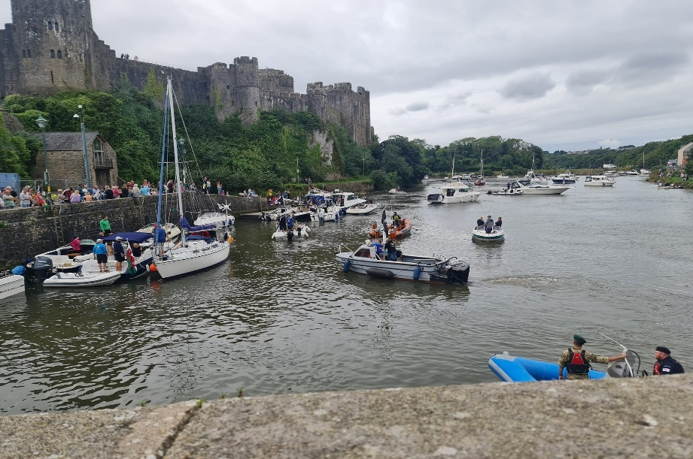

Remembering those at Freshwater West on Remembrance Day & Those who lost their lives in the Landing Craft Disaster.
80th Anniversary of D Day & Remembrance Day Pembroke
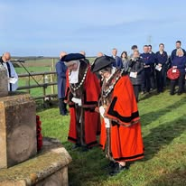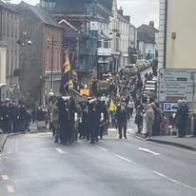
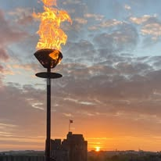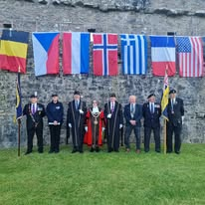
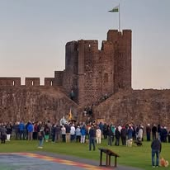

Father Christmas visits Pembroke &
Young at Heart Christmas Dinner
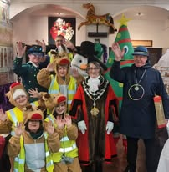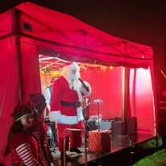

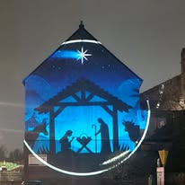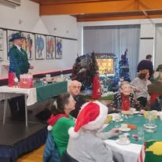

Young at Hearts 80thAnniversary of D Day
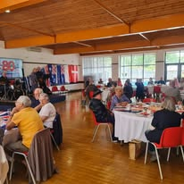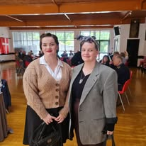

Pembroke Museum – Volunteers receive the award of full accreditation

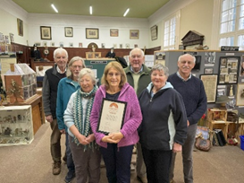
In the photograph
Museum volunteers (left to right) Ron Rees, Stuart Asman, Mary Busby, Linda Asman, George Palmer, Rose Blackburn, Roy Smith.

Contact
Pembroke Town Council
The Town Hall
Main Street
Pembroke
Pembrokeshire SA71 4JS
Tel: 01646 683092
Email: enquiries@pembroketowncouncil.co.uk
Website: www.pembroketownguide.org.uk

