PEMBROKE TOWN COUNCIL

ANNUAL REPORT 2023 - 2024

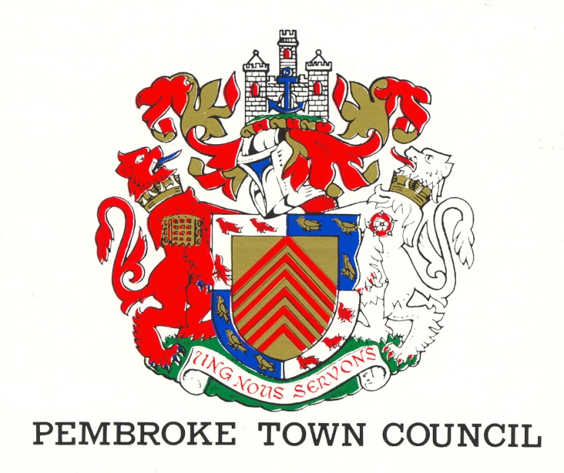
REV 3 (June 2024)
The Town Hall
Main Street
Pembroke
SA71 4JS
Tel: 01646 683092
Email: enquiries@pembroketowncouncil.co.uk
Website: www.pembroketownguide.co.uk

INTRODUCTION:
This Annual Report provides an update on our services and achievements over the last year and to see how the Council has grown and developed to meet the needs of the community.
We are required by legislation under the Local Government and Elections (Wales) Act 2021 to prepare an Annual Report. This report is also a requirement of the Well Being of Future Generations (Wales) Act 2015 and of the Environment (Wales) Act 2016.
This report will update the public, the auditor, and the Welsh Government on how we are making a difference in the town, how we are delivering against our Wellbeing Goals and on environmental issues.
This year, cost of living still causes concerns to many locals. With a Warm Welcome Café opening at Foundry House in Pembroke, to help those who may need it. Traders are still finding it difficult.

This year we have focused on:
Reconnecting with the Regeneration Committee to build a plan to put forward to and hopefully work closely with Pembrokeshire County Council, with the good news of them being awarded £10.3million towards the regeneration of Pembroke.
Still engaging with Pembrokeshire County Council (PCC) regeneration team on the South Quay development.
PEMBROKE TOWN COUNCIL:
The Council is made up of fifteen (15) councillors elected by the residents of Pembroke and the Council employs five (5) members of staff.
- Town Clerk
- Deputy Town Clerk
- Two cleaners / Caretakers
- Handyman

The gender makeup of staff and councillors can be seen below.
STAFF: COUNCILLORS:
5 15
60% female 40% female
40% male 60% male
We have four (4) County Councillors representing the four Pembroke Wards
1 Female 25% 3 Male 75%

NAME | CONTACT DETAILS
St Mary’s South Ward
Herring, Lee | 4 Moat House Cottages, Commons Road, Pembroke, SA71 4EB  07526 756620 Cllr.lee.herring@gmail.com
Jones, Gareth | Picton House, 59 Main Street, Pembroke, SA71 4DA  07973382144 pictonhouse@aol.com
Nicholas, Keith | Corner House, 1 Gibbas Way, Pembroke, SA71 5JA  01646 621374/07879337032 kkinssvs@aol.com
Willcocks, Deborah | 4 Merchants Park, Pembroke, SA71 4HD  07816 454678 Deborah.grimes@sky.com
St Mary’s North Ward
Asman, Linda | 28 Rocky Park, Pembroke, SA71 4NY  01646 622428/07584429224  linda.asman@hotmail.com
Blackburn, Rose | 13 Buttermilk Close, Pembroke, SA71 4TN  01646 681362 postmaster@rosecuts.plus.com
Bush, Daphne | Holybush Cottage, 7 Golden Brake, Pembroke, SA71 4BU  01646 681437 daphne_bush@hotmail.com
Mortenson, Ann | Charm Cottage, Lower Row, Golden Hill, Pembroke, SA71 4TG  07807129963 annmortenson@yahoo.co.uk
Monkton Ward
Cooke, Adrian | The Mews, 31 Main Street, Pembroke, SA71 4JS  07592485589 adriancooke660@gmail.com
Grimes, Jonathan | 4 Merchants Park, Pembroke, SA71 4HD  07827999448 jonathan@justgreatdesign.co.uk
Jenkins, Liz | Priory Farm, Church Terrace, Monkton, Pembroke, SA71 4LW  01646 684277 lizjenkins183@gmail.com
St Michael’s Ward
Brinn, Aden | The Garden Flat, 33 Pembroke Street, Pembroke Dock, SA72 6HX  01646 622703/07891902426 adenbrinn@aol.com
Collins, Clive | 5 Vicarage Fields, Pembroke, SA71 4AQ  01646 681500 cbros1939@gmail.com
Evans, Dennis | 17 Michael’s Road, Pembroke, SA71 5JQ  01646 683615 dw.evans939@btinternet.com
Willington, Darrell | 18 Upper Lamphey Road, Pembroke, SA71 5JL  07966182122 willers_machen@yahoo.co.uk

Register of Attendance of Ordinary Meetings of Pembroke Town Council
2023/24 | 11-May | 08-Jun | 13-Jul | no meeting | 07-Sep | 05-Oct | 09-Nov | 07-Dec | 11-Jan | 08-Feb | 07-Mar | 11-Apr
Jones G H | ü | ü | ü | NM | ü | ü | A | ü | ü | ü | ü | ü | 91%
Nicholas KN | ü | ü | A | NM | Resigned
Phillips M A | ü | ü | ü | NM | ü | A | ü | ü | A | ü | Resigned
Asman L | ü | ü | ü | NM | ü | ü | ü | ü | ü | ü | ü | ü | 100%
Blackburn R | A | ü | ü | NM | ü | ü | ü | ü | ü | ü | ü | ü | 91%
Bush D | ü | ü | ü | NM | ü | A | ü | A | ü | ü | ü | ü | 82%
Mortenson A | ü | A | A | NM | ü | ü | ü | ü | ü | ü | ü | ü | 82%
Cooke A | ü | ü | A | NM | ü | ü | ü | ü | ü | ü | A | ü | 82%
Grimes J | ü | ü | ü | NM | ü | ü | A | ü | ü | ü | A | ü | 82%
Jenkins L | ü | ü | ü | NM | ü | ü | ü | ü | ü | ü | ü | ü | 100%
Brinn A | ü | ü | ü | NM | A | ü | ü | ü | A | ü | ü | ü | 82%
Collins C | ü | ü | ü | NM | A | ü | A | ü | ü | ü | A | ü | 73%
Evans D | ü | A | A | NM | ü | ü | ü | A | A | ü | ü | ü | 64%
Willington D | A | ü | A | NM | ü | ü | ü | A | ü | ü | ü | ü | 73%
R Cowen | A | ü | ü | NM | Resigned
D Wilcox |  |  |  |  |  |  | A | ü | ü | ü | A | ü | 67%
L Herring |  |  |  |  |  |  |  | ü | ü | ü | ü | ü | 100%
Total
Suzie Thomas | ü | ü | ü | NM | ü | ü | ü | ü | ü | ü | ü | ü | 100%
Jayne Howes | ü | ü | A | NM | A | ü | ü | A | ü | ü | ü | ü | 73%

WHAT DO WE DO?
The activities of the Council can be broken down into three areas –
- Town
- Finance
- The Community

TOWN:
- We manage the office of the Mayor and Deputy Mayor of the town
- We rent out facilities within the Town Hall enabling groups such as the Pilates and the Craft and Food markets to trade
- We work with PCC on the GI (Green Infrastructure) project
- We work with the Showmen’s Guild and assist in the annual Michaelmas Fair
- We liaise with the Dyfed Powys Community Police Team and the Pembroke Street Pastors
- We work alongside Pembrokeshire County Council in the Regeneration of Pembroke
- Liaise with Transport for Wales and participate in the Train Adopter Scheme
FINANCE:
- We fund the Christmas lights and flowers within the town
- We pay 50% of the running costs to ensure that our library is kept open for the use of the community
- We fund the operating costs to ensure that the public toilets at East End are open for the use of our residents and visitors
- We finance the cost of council elections
- We provide funding to small groups within the town
- We pay for the inspection of our Play Parks
- We pay yearly to remove the algae from the Mill Pond and cut down the reeds
COMMUNITY:
- We deliver community events such as the River Rally and the Father Christmas Sleigh run
- We provide Community Governors to the two primary schools and the secondary school
- We represent the community on a number of outside agencies and companies e.g. Valero Refinery, Pembroke Power Station
- We provide a litter picking service
- We hold an annual awards evening to honour the work and dedication of residents within the town
- We house the museum in our Court room as a community facility
- Organise the Freshwater West Landing Disaster Service annually to remember those who lost their lives
- Support Ironman by opening the Town Hall and offering local charities/churches to provide refreshments for spectators and providing a compere to support the athletes taking part
- In conjunction with Pembroke Dock Town Council hold an annual Armed Forces Day
- We support the following groups and organisations within the town-
- Tanyard Youth Club
- Foundry House Community Centre
- Town Walls Trust
- Civic Trust
- Chamber of Trade
- The Freeman’s Gild of Pembroke
- Pembroke Young at Heart Group
- British Legion – Remembrance Service
- Pembroke Museum
(10) Pembroke & Monkton History Society

MAYORS TERM OF OFFICE – COUNCILLOR ADEN BRINN
The term and office of Mayor is a busy year within the municipality of our town. The Mayor is not only just the Leader of the Council but is there to represent our townspeople of our ancient and historic town of Pembroke.

During my term as Mayor, I attended in that capacity many Civic events to the various mayoralties within our County of Pembrokeshire indeed representing my Council and networking for the benefit of the town of Pembroke.

In July 2023 I attended the annual Schutzenfest in our twin town of Bergen in Lower Saxony in Germany. It enabled many discussions of strengthening our twinning arrangements with both our communities of Pembroke and Bergen. I also laid a wreath at the Obselk at the Bergen Memorial to the holocaust and laid a wreath at the grave of Ann and Margot Frank both victims who died at this concentration camp during World War 2.

September, I welcomed HMS Pembroke to our town a happy occasion but also sad as the decommissioning ceremony of our beloved ship happened in the historic setting of Pembroke Castle.

October brought much pleasure in welcoming our annual St Michaelmas Fair to our town. A much-enjoyed occasion for all where the people support this event by voting with their feet.

November, I attended many Remembrance Services in Pembroke and other towns. As Mayor I organised a Festival of Remembrance Concert at Monkton Priory Church with the Pembroke & District Male Voice Choir and which was very well attended. All proceeds went the Royal British Legion Poppy Appeal.

November was also the occasion of the Christmas Market at Pembroke Castle a well-supported event.

In March I welcomed the Burgermeister in from Bergen, Germany Frau Claudia Dettmar-Muller, and Frau Silvia Bothe their first visit and much debate ensued into our twinning arrangements for the future to be enjoyed by our respective residents and youth organisations.

April this year the annual memorial service held at Freshwater West. On this occasion the Regimental Adjutant Welsh Guards, Lt Colonel Guy Bartle-Jones laid a wreath there, acknowledging the close relationship between regiment and town.

A few days before leaving office as Mayor I signed the instrument of Town Twinning between Bain-de-Bretagne in Brittany, France, and our town of Pembroke.

Various fund-raising events were held for my chosen charities i.e. the Welsh Guards Charities and the VC Gallery and my grateful thanks for such a generous contribution from Mr Steve Thornton at Valero of the £500.00 donation made.
Total raised in my year of office was £2400.
My last duty as Mayor before leaving office was to welcome back to Pembroke Town Council a former Town Councillor and previous Mayor Cllr Keith Nicholas.

I want to thank our very hard-working Town Hall Staff for their loyalty and commitment in service not just to myself as Mayor but to the Council and the people of our town. The Town Clerk Ms Suzie Thomas, Assistant Town Clerk Mrs Jayne Howes, our caretaker Mr Dai Powell, Simon our handyman and Kaylee our cleaner well done to you all for your wonderful professionalism and dedication.

I thank in conclusion my Council in electing me as Mayor of Pembroke once again.

Pembroke is my town.
Pembroke is our town.
Pembroke is a town which we all love.

We will continue to work, preserve and dedicate the legacy for future generations to enjoy.

God Bless all the people of our great town.

Cllr Aden A. Brinn, JP
Mayor of Pembroke
2023-2024

WELLBEING GOALS FOR PEMBROKE
This year, we have invested into the Town Hall, updating the Meeting Room to provide IT equipment, to be able to hold meetings virtually, also in the Main Hall, updating the sound system and purchasing a new screen. Wi-Fi being available to users in the Main Hall, and the Meeting room. The letting of the Hall is still very positive, with many groups renting the Hall including various dance classes, keep fit, and also seen an increase of having public consultations here.
Still working with Keep Wales Tidy, we have seen an increase, on the public borrowing litter picking equipment, and also schools and organisations such as cubs/scouts etc
We also invested in employing the services of an external contractor to weed and improve the wildflower beds down at the Mill Pond, and working alongside Roots to Recovery (in Partnership with the national Trust and MIND) group they have this year tackled the following.
- Millpond Maintenance - weeding, dipping platform, fern garden creation, bind weed control (invasive species control)
- Regular litter picks around town and local area
- Picnic Area - herb box creation and planting for public use at picnic site
- Wildflower seed laying at Barnards tower to increase biodiversity along the footpath
- TO COME - Sunflower seed laying on Commons (Peter Howe)
- Engagement with local groups - Tabernacle Garden, Pembroke & Monkton History, Foundry House, West Gallery & Coffee House, Hafal, NT, Pembroke Town Team, Pembrokeshire Pride.
We have seen an uptake on the numbers of the Young at Heart coach trips, and continue to put on dinners/afternoon teas, which included this year an extra one to mark VE Day.
Here is a selection of Concerns raised by the pubic, and what Councillors have achieved in the last 12 months.
Councillor Jonathan Grimes (Town & County)
As a Town Councillor for Monkton, I have taken part in various activities, including supporting the PCC Housing Road show as well as accompanying PCC housing wardens on regular basis to visit clients.
As well as this, I have joined with the local Police on regular joint patrols around the ward and in May of 2024 had the opportunity to invite the Chief Constable of Dyfed-Powys Police to visit Monkton and meet with various community stakeholders to discuss the various issues affecting them.
I take part in regular litter-picking across Monkton and also use this time to meet with residents to discuss any issues.
Regeneration of Pembroke has continued to be high on my list of priorities and I have supported the Town Council at various regeneration meetings as well as County Council Planning Committees.
I continue to be a Governor at Monkton Priory School and a Trustee at the Tanyard Youth Group.
I also sit on the Town Twinning Committee and visited Bergen in Germany in 2023 as part of our long-standing twin town relationship.
Councillor Gareth Jones
I continue to work with the Town Council, neighbouring communities, and the Royal British Legion to deliver remembrance events. As Town Crier, I promote events and causes within the Community of Pembroke. Supporting Santa's Sleigh through Pembroke and Monkton. I also Chair the Pembroke Young at Heart Committee delivering Trips, events, and support.
Councillor Keith Nicholas
I think it is very important for Councillors just to be at the end of a phone or home visit to deal with issues as they arise.
Most of our issues we have to move to County Councillors for them to take up at County level.
However, some of the concerns I have dealt with and passed to relevant bodies to get answers have been Broadband Issues, Untidy Hedgerows, Playing areas needing cutting etc.
Previously I have been involved in many fundraising events in the community which is great as you also talk to our local ward members.
I look forward in the future just being there to help the community when called and promote Pembroke in any way I can.
Councillor Deborah Willcocks
I was contacted by a resident concerned about a late-night licensing application, I kept her fully informed and went to the licensing committee meeting to support the local County Councillor, who spoke against the late opening.
I was contacted by a concerned resident about horses on the commons play area. I worked with the County Councillor and kept the resident informed of what was being done and the eventual outcome.

Councillor Darrell Willington
I have reported a number of things to our ward county councillor and PCSO....with some limited actions taking place.
Councillor Adrian Cooke
County Councillor Phillips and myself plant up the Pembroke station every year.
I support my ward's coffee mornings every week and often bake cakes for them.
I have done flower demonstrations in Monkton church.
Instrumental in arranging the church flower festival.

Councillor Liz Jenkins
Residents have contacted me with various problems in Monkton. I passed this information to County Councillor Jonathan Grimes who had arranged a walkabout meeting with all the relevant officers concerned.
Councillor Dennis Evans
I have continued to support the residents of St Michaels Ward ensuring that concerns raised have been answered in a timely manner. I have been heavily involved in ensuring that our Standing Orders and Policy documents are reviewed and updated as required. I was appointed Chair of the reformed Regeneration Committee and I have also represented Council on a number of external committees such as the liaison committees of the Power Station and Valero Oil Refinery and as a governor at Golden Grove / Gelli Aur school.

Councillor Linda Asman

As Town Councillor for my ward of St Mary’s North, I have worked closely with both the Community group, Green Park Pembroke and PTC in raising money for new park equipment. On May 27th, a Party in the Park was organised to mark the official opening and to thank the funders – PCC (Enhancing Pembrokeshire Fund), Valero, Co-op and Pembroke Town Council. It was a lovely community event with so many taking part in glorious sunshine and refreshments generously supplied by the Green Garage.
As well as Town Councillor, I am Chair of the Pembroke & Monkton Local History Society and work closely with Pembroke Town Council in delivering heritage projects to enhance the town. A big success story has been Pembroke Museum. Owned by PTC and housed in the former magistrate’s courtroom, it is managed entirely voluntarily by the volunteers of the History Society. I also act as Hon. Curator. The Town Hall with its museum, Murals and Council Chamber is proving a popular visitor attraction and has been awarded the accreditation of ‘Quality Assured Visitor Attraction’ by Visit Wales.
The History Society exists to promote Pembroke’s heritage and to this end, I also organise a series of history talks and fundraising events in the Town Hall.

I work conscientiously for this Council and have a 100% attendance at council meetings regularly raising concerns particularly on conservation matters. There has been much opposition to the South Quay Phase 2 plans and, along with Co Cllr Jonathan Grimes and Peter Thomas of Pembroke Civic Trust, I have been active in voicing Pembroke Town Council’s concerns at meetings of PCC’s planning committee.

SUMMARY OF RECEIPTS AND PAYMENTS
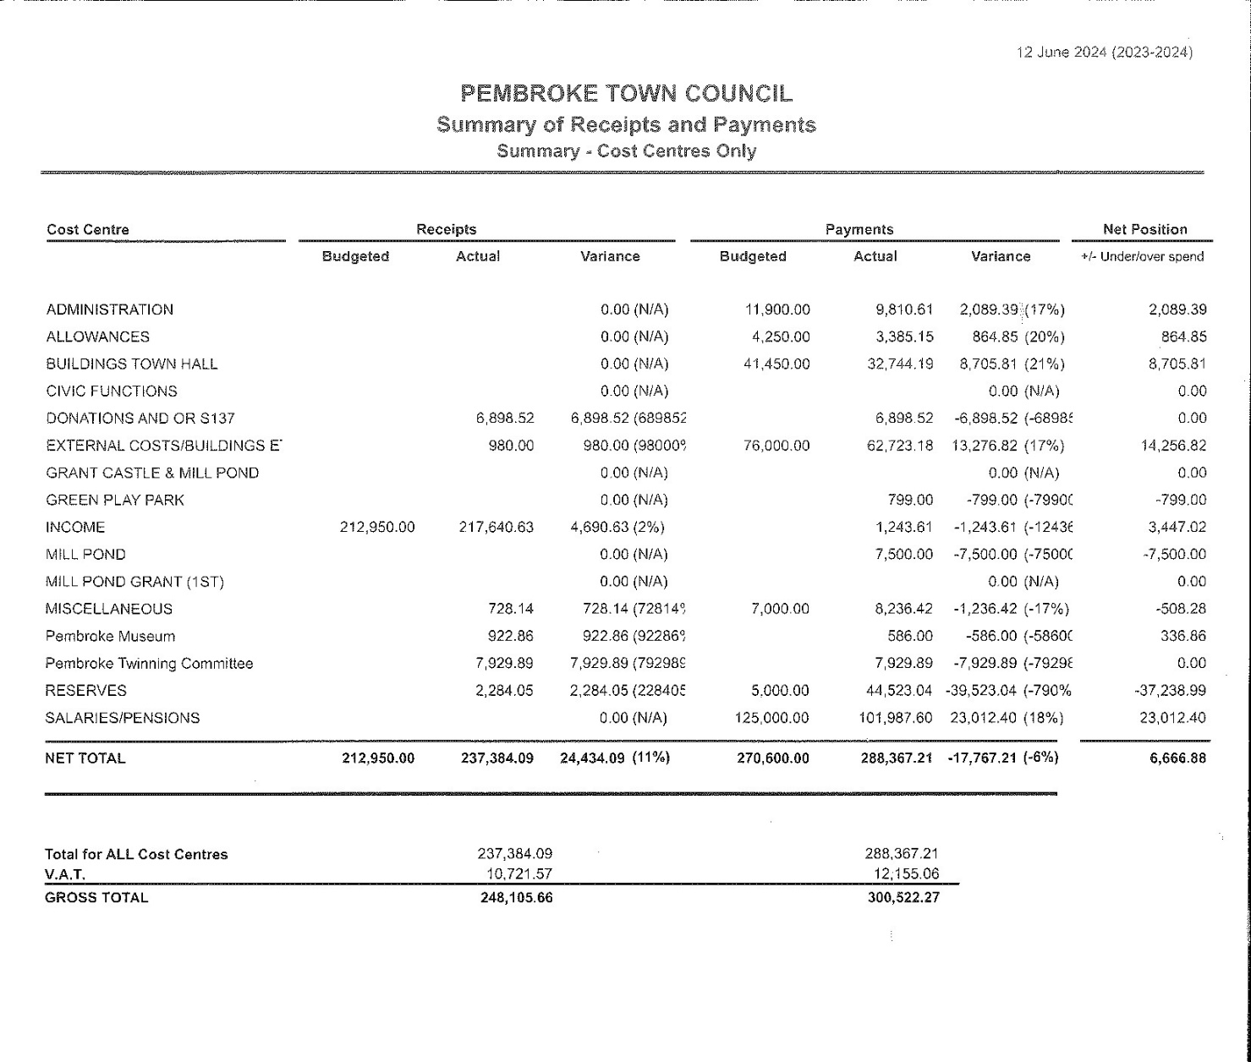
References:
Local Government and Elections (Wales) Act 2021
Wellbeing of Future Generations (Wales) Act 2015
Environment (Wales) Act 2016
Pembroke Town Council – Wellbeing and Future Generations Policy 2021
Pembroke Town Council – Standing Orders
Pembroke Town Council – Welsh Language Policy

A Year in Pictures
Pembroke Civic Awards

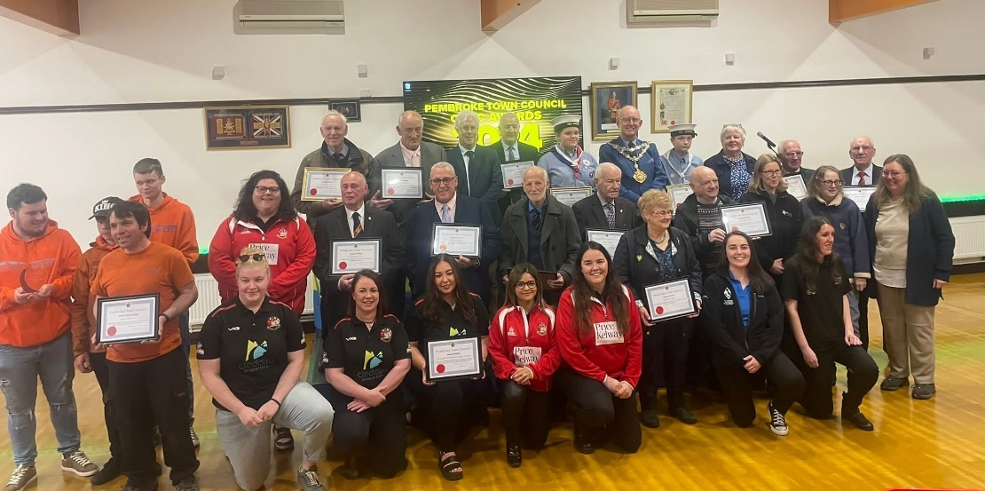

Pembroke Michaelmas Fair
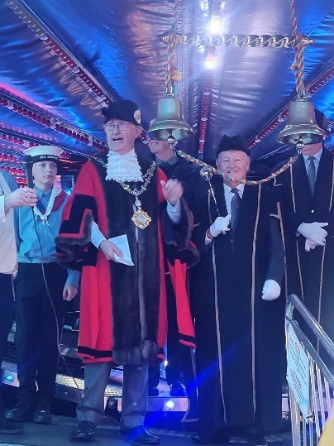

Pembroke River Rally
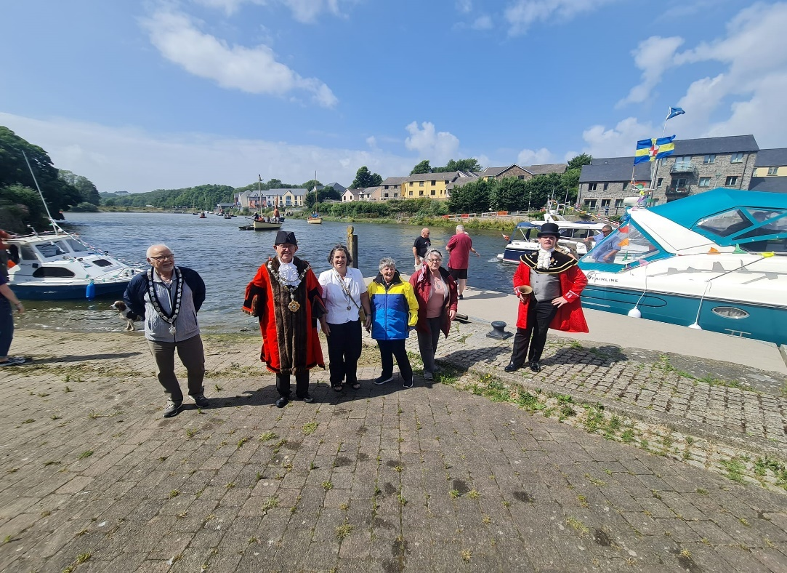

Remembering those at Freshwater West on Remembrance Day & Those who lost their lives in the Landing Craft Disaster

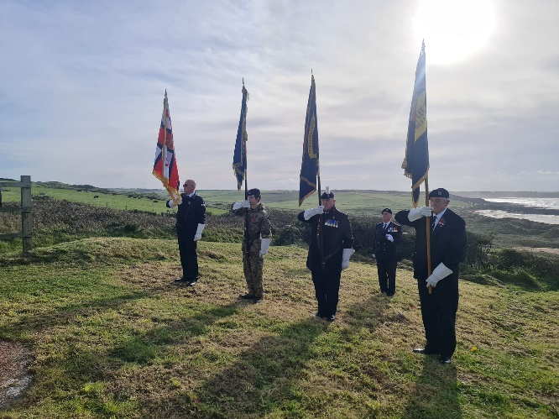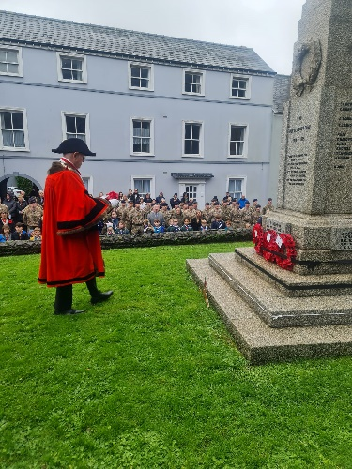

Presentation
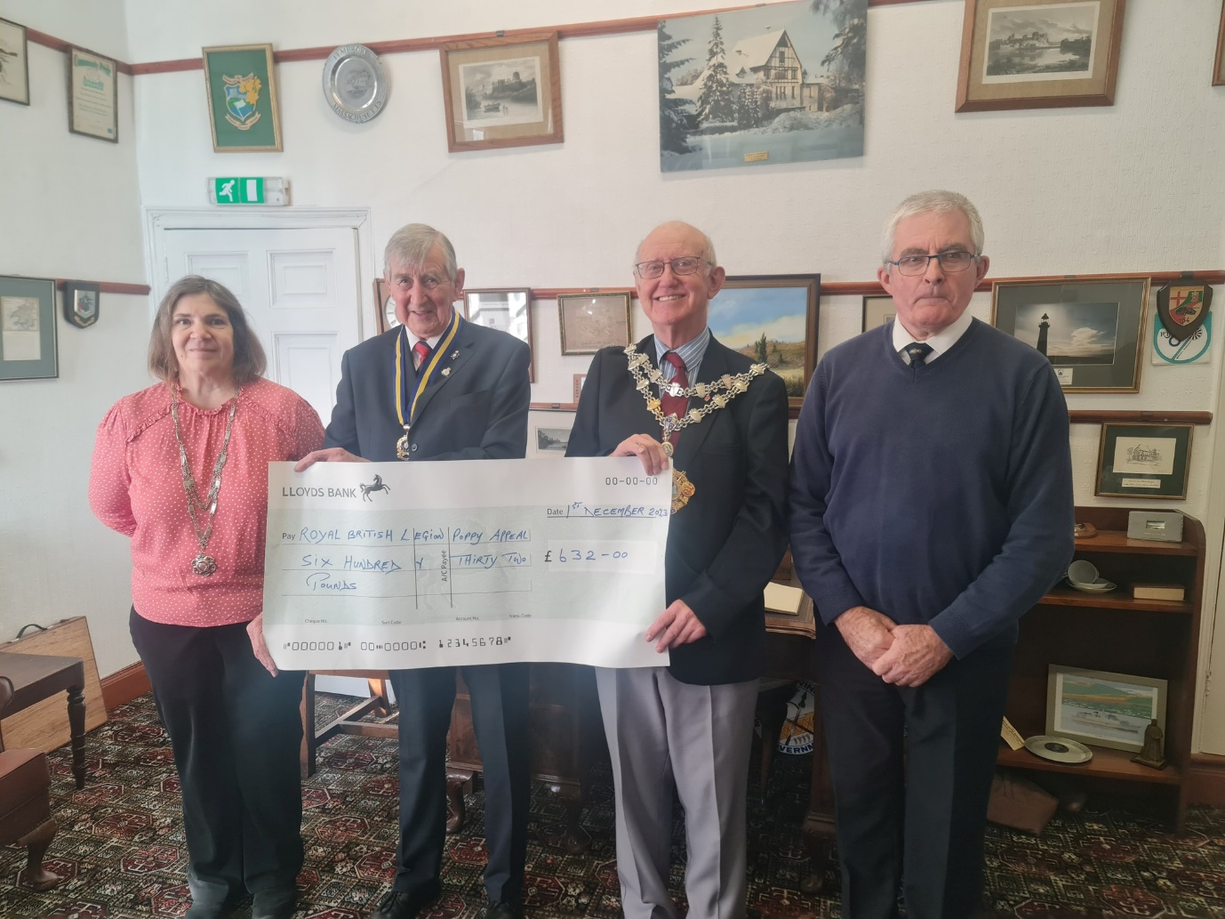

Father Christmas visits Pembroke
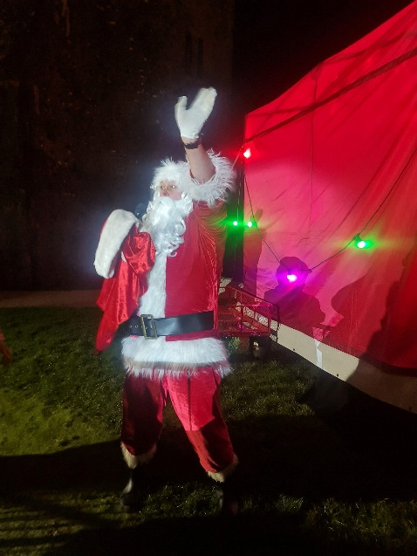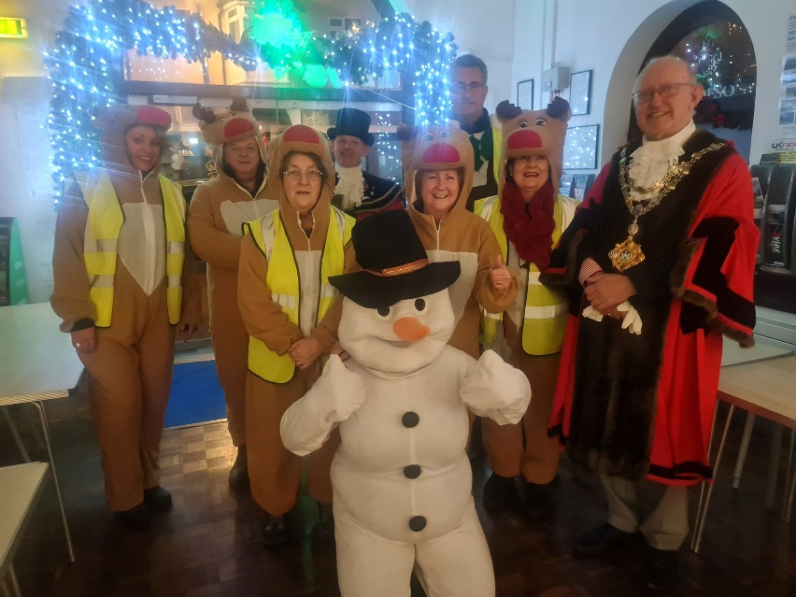

Mayor’s fundraising Concert
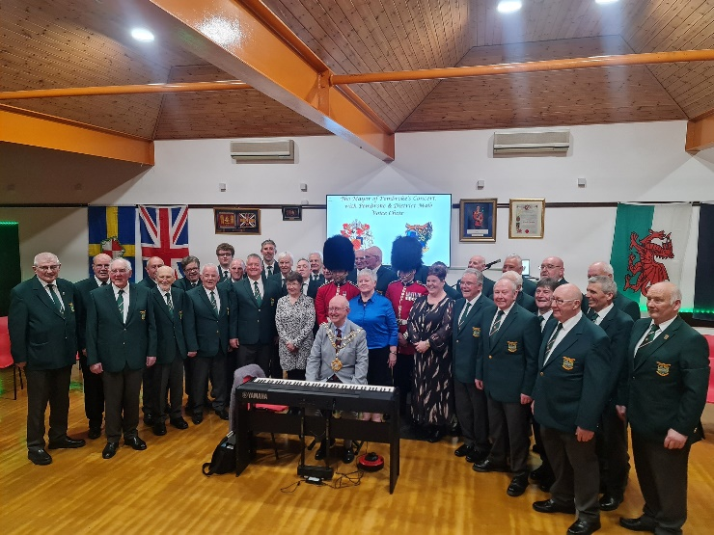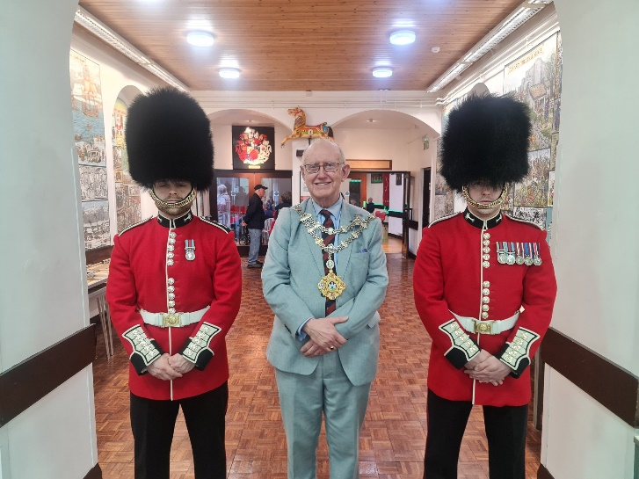

Contact
Pembroke Town Council
The Town Hall
Main Street
Pembroke
Pembrokeshire SA71 4JS
Tel: 01646 683092
Email: enquiries@pembroketowncouncil.co.uk
Website: www.pembroketownguide.org.uk

