PEMBROKE TOWN COUNCIL

ANNUAL REPORT 2022 - 2023

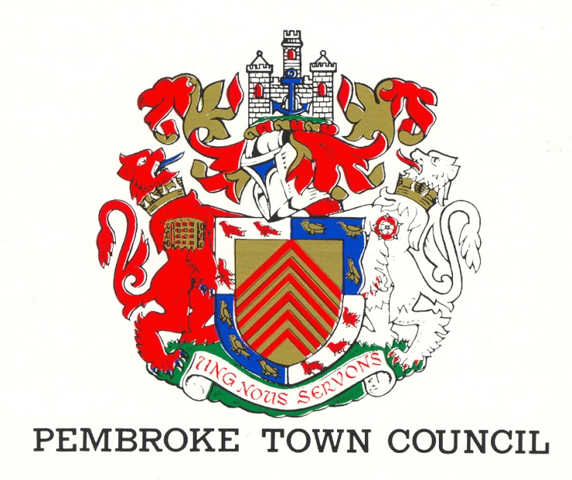
REV 2 (June 2023)
The Town Hall
Main Street
Pembroke
SA71 4JS
Tel: 01646 683092
Email: enquiries@pembroketowncouncil.co.uk
Website: www.pembroketownguide.co.uk

INTRODUCTION:
This Annual Report provides an update on our services and achievements over the last year and to see how the Council has grown and developed to meet the needs of the community.
We are required by legislation under the Local Government and Elections (Wales) Act 2021 to prepare an Annual Report. This report is also a requirement of the Well Being of Future Generations (Wales) Act 2015 and of the Environment (Wales) Act 2016.
This report will update the public, the auditor, and the Welsh Government on how we are making a difference in the town, how we are delivering against our Wellbeing Goals and on environmental issues.
This year has been a difficult one for many, with the war in Ukraine, and energy cost prices reaching a record high, with many finding the cost of living a struggle. Residents finding it a daily struggle to fuel their car and put food on the table. Likewise, many traders in our Town have found it a difficult year, with increased costs, and people watching what their hard-earned money is spent on. In times of crisis, it is imperative that the Town Council work closely with the local community.
This year we have focused on:
- Funding Local Food Banks
- Part - Funded Local Play Area for new play equipment
- Renewed Contract to pay for the Blackhorse Toilets to stay open
- Engaged with Local schools, inviting them into the Town Hall
- Invested in a new lift in the Town Hall
- Set up a new Twinning with Bain – de Bretagne, France
Still engaging with Pembrokeshire County Council (PCC) regeneration team on the South Quay development.
PEMBROKE TOWN COUNCIL:
The Council is made up of fifteen (15) councillors elected by the residents of Pembroke and the Council employs five (5) members of staff.
- Town Clerk
- Deputy Town Clerk
- Two cleaners / Caretakers
- Handyman

The gender makeup of staff and councillors can be seen below.
STAFF: COUNCILLORS:
5 15
60% female 47% female
40% male 53% male
We have four (4) County Councillors representing the four Pembroke Wards
1 Female 25% 3 Male 75%

NAME | CONTACT DETAILS
St Mary’s South Ward
Cowen, Rhian | The Apple Tree, 12 Church Terrace, Monkton, SA71 4LN  07788231606 rhiancowen@gmail.com
Jones, Gareth | Picton House, 59 Main Street, Pembroke, SA71 4DA  07973382144 pictonhouse@aol.com
Nicholas, Keith | Corner House, 1 Gibbas Way, Pembroke, SA71 5JA  01646 621374/07879337032 kkinssvs@aol.com
Phillips, Melanie | 6 Harcourt Terrace, Pembroke, SA71 4BP  01646 682308 melaniephillips@talktalk.net
St Mary’s North Ward
Asman, Linda | 28 Rocky Park, Pembroke, SA71 4NY  01646 622428/07584429224  linda.asman@hotmail.com
Blackburn, Rose | 13 Buttermilk Close, Pembroke, SA71 4TN  01646 681362 postmaster@rosecuts.plus.com
Bush, Daphne | Holybush Cottage, 7 Golden Brake, Pembroke, SA71 4BU  01646 681437 daphne_bush@hotmail.com
Mortenson, Ann | Charm Cottage, Lower Row, Golden Hill, Pembroke, SA71 4TG  07807129963 annmortenson@yahoo.co.uk
Monkton Ward
Cooke, Adrian | The Mews, 31 Main Street, Pembroke, SA71 4JS  07592485589 adriancooke660@gmail.com
Grimes, Jonathan | 4 Merchants Park, Pembroke, SA71 4HD  07827999448 jonathan@justgreatdesign.co.uk
Jenkins, Liz | Priory Farm, Church Terrace, Monkton, Pembroke, SA71 4LW  01646 684277 lizjenkins183@gmail.com
St Michael’s Ward
Brinn, Aden | The Garden Flat, 33 Pembroke Street, Pembroke Dock, SA72 6HX  01646 622703/07891902426 adenbrinn@aol.com
Collins, Clive | 5 Vicarage Fields, Pembroke, SA71 4AQ  01646 681500 cbros1939@gmail.com
Evans, Dennis | 17 Michael’s Road, Pembroke, SA71 5JQ  01646 683615 dw.evans939@btinternet.com
Willington, Darrell | 18 Upper Lamphey Road, Pembroke, SA71 5JL  07966182122 willers_machen@yahoo.co.uk

Register of Attendance of Ordinary Meetings of Pembroke Town Council
2022/23 | 19-May | 16-Jun | 14-Jul | no meeting | 08-Sep | 06-Oct | 10-Nov | 08-Dec | 12-Jan | 09-Feb | 09-Mar | 06-Apr
 |  |  |  |  | Meeting Cancelled Queen
Jones G H | ü | ü | A | NM | NM | ü | ü | ü | ü | ü | ü | ü | 92%
Nicholas KN | ü | ü | A | NM | NM | ü | ü | ü | ü | ü | ü | A | 83%
Llewellyn P | ü | A | A | NM | NM | A | Resigned
Phillips M A | ü | A | ü | NM | NM | ü | A | ü | ü | ü | A | A | 66%
Asman L | ü | ü | ü | NM | NM | ü | ü | ü | ü | ü | A | ü | 92%
Blackburn R | ü | ü | ü | NM | NM | ü | ü | ü | ü | ü | A | ü | 92%
Bush D | ü | A | A | NM | NM | ü | ü | A | ü | ü | ü | A | 66%
Mortenson A | ü | A | ü | NM | NM | ü | ü | ü | ü | ü | ü | ü | 92%
Cooke A | ü | ü | ü | NM | NM | ü | No A | ü | ü | ü | ü | A | 83%
Grimes J | ü | A | ü | NM | NM | ü | A | ü | A | ü | ü | ü | 75%
Jenkins L | ü | ü | ü | NM | NM | ü | ü | ü | ü | A | ü | ü | 92%
Brinn A | ü | A | ü | NM | NM | ü | A | ü | A | ü | ü | ü | 75%
Collins C | ü | ü | ü | NM | NM | A | A | ü | ü | ü | ü | ü | 83%
Evans D | ü | ü | ü | NM | NM | ü | ü | ü | ü | ü | ü | ü | 100%
Willington D | ü | ü | ü | NM | NM | A | ü | ü | ü | A | ü | ü | 83%
R Cowen |  |  |  |  |  |  |  | ü | ü | ü | ü | ü | 100%
Total
Suzie Thomas | ü | ü | ü | NM | NM | ü | ü | A | ü | ü | ü | ü | 92%
Jayne Howes | ü | ü | ü | NM | NM | A | ü | ü | A | ü | ü | ü | 83%

WHAT DO WE DO?
The activities of the Council can be broken down into three areas –
- Town
- Finance
- The Community

TOWN:
- We manage the office of the Mayor and Deputy Mayor of the town
- We rent out facilities within the Town Hall enabling groups such as the Pilates and the Craft and Food markets to trade
- We work with PCC on the GI (Green Infrastructure) project
- We work with the Showmen’s Guild and assist in the annual Michaelmas Fair
- We liaise with the Dyfed Powys Community Police Team and the Pembroke Street Pastors
- We work alongside Pembrokeshire County Council in the Regeneration of Pembroke
- Liaise with Transport for Wales and participate in the Train Adopter Scheme
FINANCE:
- We fund the Christmas lights and flowers within the town
- We pay 50% of the running costs to ensure that our library is kept open for the use of the community
- We fund the operating costs to ensure that the public toilets at East End are open for the use of our residents and visitors
- We finance the cost of council elections
- We provide funding to small groups within the town
- We pay for the inspection of our Play Parks
- We pay yearly to remove the algae from the Mill Pond and cut down the reeds
COMMUNITY:
- We deliver community events such as the River Rally and the Father Christmas Sleigh run
- We provide Community Governors to the two primary schools and the secondary school
- We represent the community on a number of outside agencies and companies eg Valero Refinery, Pembroke Power Station
- We provide a litter picking service
- We hold an annual awards evening to honour the work and dedication of residents within the town
- We house the museum in our Court room as a community facility
- Organise the Freshwater West Landing Disaster Service annually to remember those who lost their lives
- Support Ironman by opening the Town Hall and offering local charities/churches to provide refreshments for spectators and providing a compere to support the athletes taking part
- In conjunction with Pembroke Dock Town Council hold an annual Armed Forces Day
- We support the following groups and organisations within the town-
- Tanyard Youth Club
- Foundry House Community Centre
- Town Walls Trust
- Civic Trust
- Chamber of Trade
- The Freeman’s Gild of Pembroke
- Pembroke Young at Heart Group
- British Legion – Remembrance Service
- Pembroke Museum
(10) Pembroke & Monkton History Society

MAYORS TERM OF OFFICE – COUNCILLOR DENNIS EVANS
The role of the Mayor can be multi-faceted but representation is probably the key one. The Mayor not only represents the Council but represents the residents of the town and to some extent the tourists that come to the town as well.
One of my first duties as Mayor was to welcome one new councillor, Darrell Willington and an old friend Pearl Llewellyn to Council. Unfortunately, later in the year Pearl stepped down because of health issues and following co-option interviews another new face joined Council, Rhian Cowan.
During my term of office, I attended Mayoral Civic events in Tenby, Haverfordwest, Narberth, Fishguard and Pembroke Dock and it gave every new Mayor an opportunity to meet up and to re-establish the ever popular “chain gang”.
I attended a number of other “formal” events such as the memorial services to our late Queen in St David’s Cathedral and St. Mary’s Church Pembroke and the 40th. year celebrations for the Paul Sartori Hospice for home charity.
On a more poignant note, the Mayoress and myself attended remembrance services in Freshwater West, the military cemetery Pembroke Dock, Pembroke Dock service, the Landing Craft Service at Freshwater West and our own service at the cenotaph.
HMS Pembroke paid a courtesy visit to the Haven and during the visit I was able to host a reception for the Commander, officers and some of the ratings.
As Mayor you are invited to a number of fun events, such as, Beating the Bounds ceremony in Haverfordwest, the opening of the fairs in Haverfordwest, Neath and Hereford and of course our own fair and prize giving at Ysgol Gelli Aur / Golden Grove school just to name a few.
Christmas was a very busy time for us and one of our first events was to open the Christmas Market at the Castle and that night Father Christmas joined us on the sleigh ride through town. It was truly a fantastic night with throngs of adults and children following the sleigh up to St Michael’s Square for the carol singing. Attending a Christmas concert at St. Mary’s Church, the Young at Heart Christmas lunch and delivering food parcels to the Bethal food bank in Pembroke Dock were just some of the events leading up to Christmas Day.
In addition, my Chaplain organised a Christmas Carol concert in the Town Hall and we were also invited to open the Tanyard Christmas Fair. I also had the pleasure of delivering boxes of biscuits to South Pembs Hospital, Ashdale, Bush and Holyland nursing homes.
One of my key interests was to invite our young people into the Town Hall and to visit the Chamber in order to take part in debates. Visits were organised for the cubs and scouts, the school Councils from Ysgol Gelli Aur / Golden Grove and Monkton Schools. Each session included a question and answer session and believe me some of the questions asked were well thought out and searching.
On Sunday March 12th. it was a pleasure and an honour to be involved in the parade through Main Street of some 300 RAF Air Cadets led by the cadet band featuring 60 musicians. The parade ended in the grounds of Pembroke Castle and I would like to think that the young men and women would remember the occasion for some-time to come, I certainly will.
The 80th. anniversary of the Landing Craft disaster took place in April and the Mayoress and myself attended and I laid a wreath on behalf of Council.
With the lead up to the Coronation and the end of my term of office, there were a flurry of events and invitations which included an invite to the Street Pastor AGM, an organisation which undertakes such valuable work within the town.
We were invited to the Young at Heart Coronation Tea, made visits to Ysgol Gelli Aur / Golden Grove and Monkton schools in order to distribute the Coronation Book- Marks. In addition, we planted a Coronation tree down by the William Marshal statue.
One of my priorities throughout the year has been to assist in the updating of existing procedures, developing new ones and ensuring that our Standing Orders are the latest versions being used.
Being on the liaison committees of Valero and the Power station I have been keenly interested of any developments on the two sites and I look forward to playing an important role on any committee set up by the Milford Haven Port Authority.
Of the eleven monthly meetings held, I had the good fortune to attend all of them as Mayor but is was at the very start of the September meeting that we heard the very sad news that the Queen had passed away. Great sadness was expressed by all present and as Operation London Bridge came into being I curtailed the meeting out of respect to her Majesty.
During the year we had a number of guest speakers, for example, Town Walls Trust, Welsh Water & NRW, Milford Haven Port Authority to name just a few.
During the year the lift in the Town Hall was brought back into action and we installed hybrid communications in the Council Chamber. However, there are still issues, the South Quay development being the most important one and the success or failure of this project will have ramifications in the town for many years to come.
I would like to thank our Council staff for their continued loyalty and in particular our Town Clerk and Deputy Town Clerk. Unfortunately, one of our long serving caretakers Rose, resigned in February after giving excellent service to the Council and the Town. We did however recruit a new caretaker, Dave Powell and we wish him well for his future employment with us. During the year I had the pleasure to inform Council that Cllr. Rose Blackburn had been awarded the British Empire Medal (BEM) for her work in the community but sad also that she had decided to step down as Town Crier. We were very fortunate that Cllr. Gareth Jones was very keen to take on the Town Crier duties and we wish him well.
My charity for the year was the Paul Satori hospice for home Charity, and I am pleased to report that I with the help of many other people raised £2,024 for the Charity.
My final act as Mayor was to Chair the AGM when the Mayor Elect was voted in as the Mayor for ensuing year.
Finally, I would like to thank my fellow councillors for giving me the opportunity to become Mayor of Pembroke for a second term, it was certainly an honour and a privilege to represent Council and the residents of such an historic town.

WELLBEING GOALS FOR PEMBROKE

We believe that Pembroke is a town that should be inclusive, and we will make a point of engaging with residents of different back grounds, but we must continue to listen to the thoughts of everyone in the community.
During the year the Mayor and Town Clerk visited a number of businesses in the town, engaging with the owners and staff on what issues and challenges face them in times of financial insecurity. This was seen as a very positive way forward with excellent feedback.
Another way of engaging with the residents of the town was the formation of a Town Team. They have been very proactive, and a number of events have been organised to coincide

with the lead up to the Coronation. Initial help was given by Council, but the team are determined to become a self- funding organisation.
The “Keep Wales Tidy litter picking Hub” is still active and reminding members of the public that litter picking equipment is available for them to use. The “Routes to Recovery” programme organised by PCC and working alongside MIND is still on-going enabling unkempt areas within the town to be tidied up.
A dipping platform has been constructed at the eastern end of the Mill Pond for the use of the junior schools with- in the town.
The “Young at Heart “group continues to flourish under a new committee structure but still provides dinners and coach trips for the group members. This is seen as an excellent but essential process in engaging with members of the public of “a certain age”.
Engaging with our younger residents is a top priority and with financial help from Town Council, County Council, local businesses (Asona Group, Valero and Co-opeartive) a fully refurbished play park in St. Mary’s North Ward is now up and running. This was initiated by Councillor Linda Asman, who together with a newly formed Community Group worked together and for this to succeed engagement was sought by the parents of children using the facility but also involvement form households adjacent to the park.
Groups of children have been encouraged to visit the Town Hall and the Council Chamber with School Councils holding debates and question and answer sessions in the Chamber.
Council continues to engage with PCC with regard to the South Quay development, attending meetings and having Council representation on the Development Trust.
There is an established process for the Community Safety Partnership with the local police. On a regular basis, Councillors are contacted by the police asking if they have any concerns or issues.
There is a continual review of policies and procedures and Standing Orders are updated when necessary. Staff contracts have been reviewed and the Employment Handbook is in the process of being updated.

SUMMARY OF RECEIPTS AND PAYMENTS

References:
Local Government and Elections (Wales) Act 2021
Wellbeing of Future Generations (Wales) Act 2015
Environment (Wales) Act 2016
Pembroke Town Council – Wellbeing and Future Generations Policy 2021
Pembroke Town Council – Standing Orders
Pembroke Town Council – Welsh Language Policy

A Year in Pictures
Pembroke Civic Awards

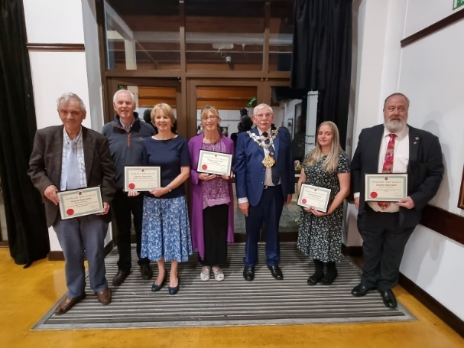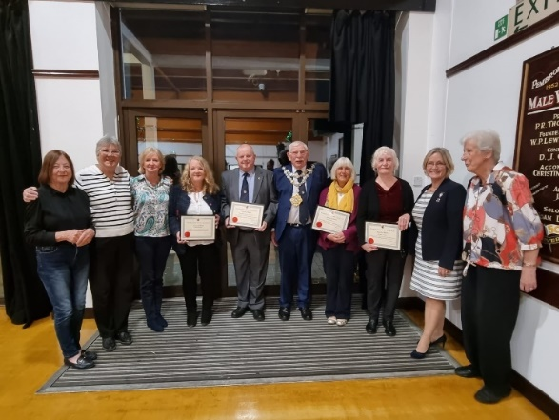

Pembroke Michaelmas Fair
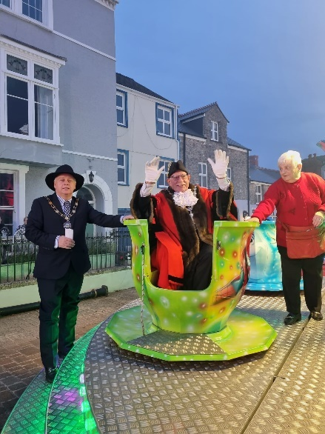
Pembroke River Rally
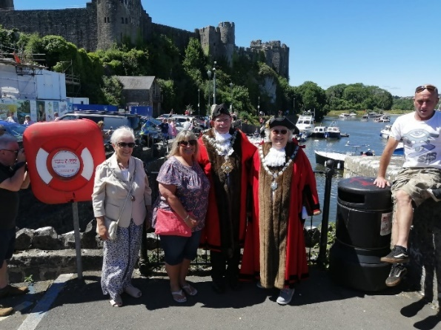

Remembering those at Freshwater West on Remembrance Day & Those who lost their lives in the Landing Craft Disaster
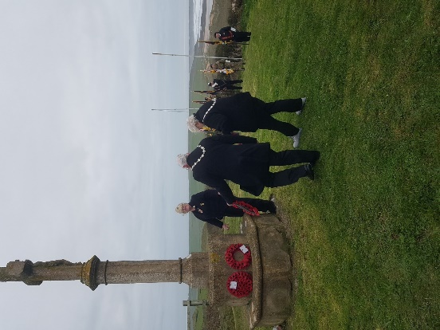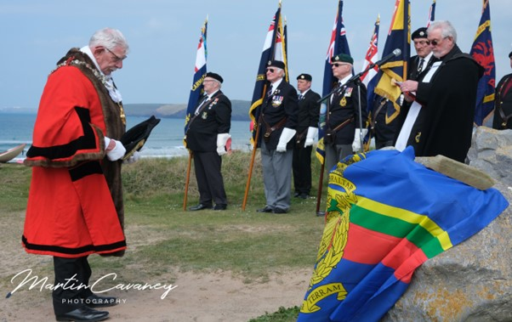
300 RAF Air Cadets led by the cadet band featuring 60 musicians. The parade ended in the grounds of Pembroke Castle
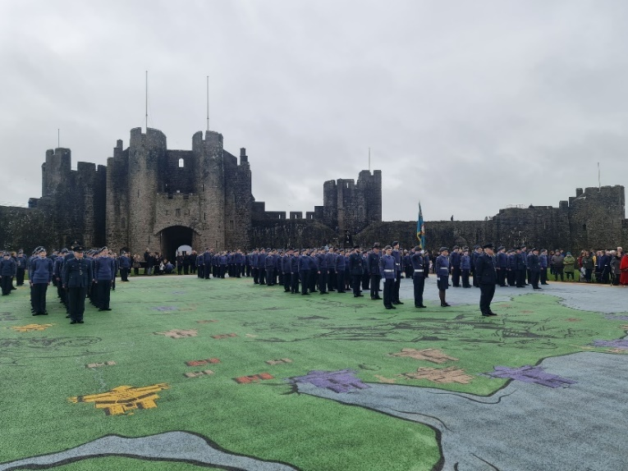

Pembroke Young at Heart Christmas Dinner
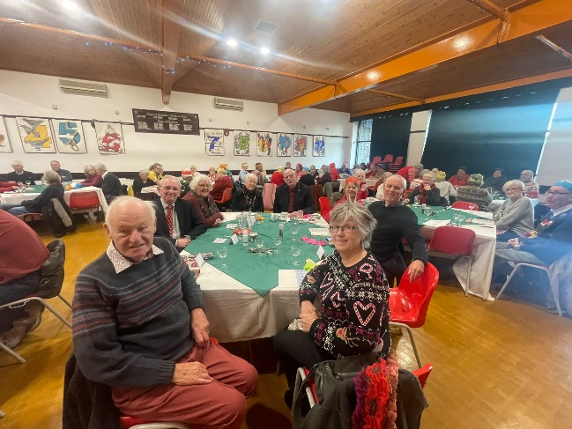

Father Christmas visits Pembroke

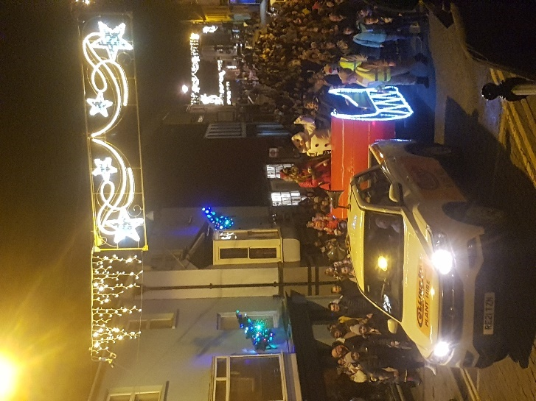

Presenting Bookmarks to the local schools to mark the Coronation of King Charles III & A Royal Coronation Afternoon Tea

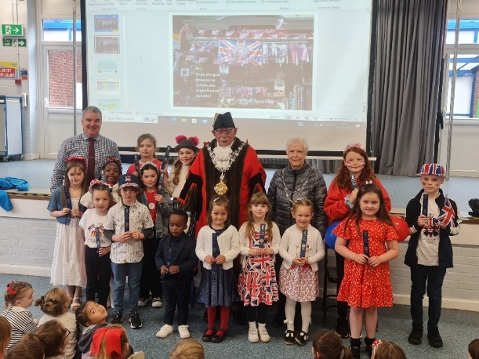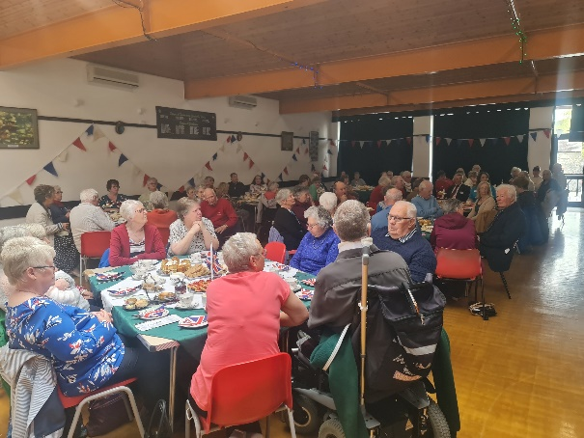
Contact
Pembroke Town Council
The Town Hall
Main Street
Pembroke
Pembrokeshire SA71 4JS
Tel: 01646 683092
Email: enquiries@pembroketowncouncil.co.uk
Website: www.pembroketownguide.org.uk

