PEMBROKE TOWN COUNCIL

ANNUAL REPORT 2021 - 2022

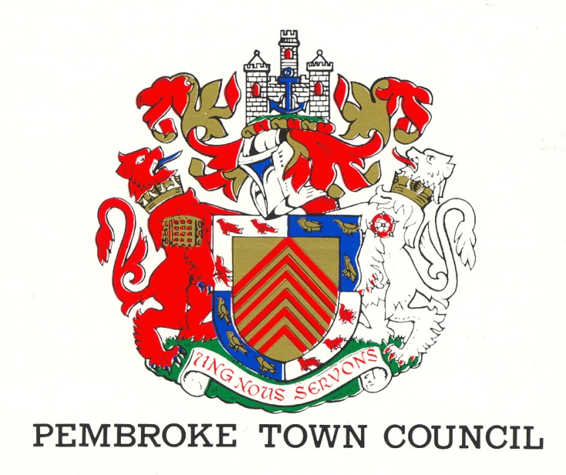
REV 1 (September 2022)
The Town Hall
Main Street
Pembroke
SA71 4JS
Tel: 01646 683092
Email: enquiries@pembroketowncouncil.co.uk
Website: www.pembroketownguide.co.uk

INTRODUCTION:
This Annual Report provides an update on our services and achievements over the last year and to see how the Council has grown and developed to meet the needs of the community.
We are required by legislation under the Local Government and Elections (Wales) Act 2021 to prepare an Annual Report. This report is also a requirement of the Well Being of Future Generations (Wales) Act 2015 and of the Environment (Wales) Act 2016.
This report will update the public, the auditor, and the Welsh Government on how we are making a difference in the town, how we are delivering against our Wellbeing Goals and on environmental issues.
Despite the setbacks of the Covid -19 pandemic 2020 – 2021 we as a Council have continued to operate, keeping in mind the wellbeing of our employees and of the community as a whole. The Town Hall remained open with strict guidelines of allowing only 2 in at a time.
During that time, we entered into the digital age by continuing to hold our Council meetings using the Zoom facility. Despite encountering some early problems, they were mostly overcome and as a result Council business carried on pretty much as normal.
A lighter workload gave us the opportunity to review and revise some of our procedures and work practices.
- Introduction of virtual meeting using the Zoom facility
- Review of our employee contracts
- Introduced hybrid working for our office staff
- Updated our Health and Safety, First Aid and Manual Handling training for all of our employees.
- Developed a Wellbeing and Future Generations Policy
- Updated our Standing Orders
- We have updated our Web Site and use Facebook to advertise Council activities
- We continued to fund local groups
- We invested in technology by introducing internet connection into the Council chamber ensuring that councillors and residents are able to take part in Council meetings from their remote locations
- We review planning applications applicable to the town and make representation regarding our decisions to PCC
We are engaging with Pembrokeshire County Council (PCC) regeneration team on the South Quay development and are in the process of developing a “Vision for Pembroke” re-generation plan.
PEMBROKE TOWN COUNCIL:
The Council is made up of fifteen (15) councillors elected by the residents of Pembroke and the Council employs five (5) members of staff.
- Town Clerk
- Deputy Town Clerk
- Two cleaners / Caretakers
- Handyman
The gender makeup of staff and councillors can be seen below.
STAFF: COUNCILLORS:
5 15
80% female 25% female
20% male 75% male
We have four (4) County Councillors representing the four Pembroke Wards
1 Female 25% 3 Male 75%

Pembroke Town Councillors
Collins CJ (Clive)  St Michael | 5 Vicarage Fields, Pembroke, SA71 4AQ   681500  cbros1939@gmail.com
Cooke (Adrian)  Monkton | The Mews, 31 Main Street, Pembroke, SA71 4JS   07592485589  adriancooke660@gmail.com
Nicholas KN (Keith)  St Mary (South) | 61 Main Street, Pembroke, SA71 4DA   621374  Kkinssvs@aol.com
Brinn AA (Aden)  St Michael | The Garden Flat, 33 Pembroke Street, SA72 6HX   622703  adenbrinn@aol.com
Blackburn MR (Rose)  St Mary (North) | 13 Buttermilk Close, Pembroke, SA71 4TN   681362  Postmaster@rosecuts.plus.com
Carey AL (Aaron)  St. Michael | 1 South Meadows, Pembroke, SA714EW   07917733833  aaroncarey1@hotmail.com
Nutting Nutting JAR (Jon)  St Michael | 138 – 140 Main Street, Pembroke, SA71 4HN   682537  johnpoyer@gmail.com
Phillips MA (Melanie)  St Mary (South) | 6 Harcourt Terrace, Pembroke, SA71 4BP   682308  melaniephillips@talktalk.net
Evans DW (Dennis)  St Michael | 17 St. Michael’s Road, Pembroke, SA71 5JQ   683615  dw.evans939@btinternet.com
Asman LA (Linda)  St Mary (North) | 28 Rocky Park, Pembroke, SA71 4NY   622428 07584429224  linda.asman@hotmail.com
Bush (Daphne)  St Mary (North) | Holybush Cottage, 7 Golden Brake, Pembroke SA71 4BU   01646 681437  Daphne_bush@hotmail.com
Grimes (Jonathan)  Monkton | 4 Merchants Park, Pembroke SA71 4HD    07827999448   jonathan@justgreatdesign.co.uk
Brown LL (Linda)  Monkton  Jones (Gareth)  St Mary (South) | Priory Villa, Monkton, Pembroke SA71 4HP   07747774759 / 622723  wantonwax@aol.com  Picton House, 59 Main Street, Pembroke, SA71 4DA    07973 382144  pictonhouse@aol.com
Mortenson (Ann)  St Mary (North) | Charm Cottage, Lower Row, Golden Hill, Pembroke, SA71 4TG   07807129963   annmortenson@yahoo.co.uk

In order to comply with the COVID-19 conditions, the Mayor for the period 2021 – 2022 was elected by using the virtual facility, ZOOM.

Register of Attendance of Ordinary Meetings of Pembroke Town Council
2021/22 | 13-May | 17-Jun | 15-Jul | 12-Aug | 09-Sep | 07-Oct | 10-Nov | 09-Dec | 13-Jan | 09-Feb | 10-Mar | 07-Apr | %
Jones G H | ü | ü | A | ü | ü | ü | A | ü | ü | ü | ü | ü | 83.33%
Nicholas KN | ü | A | A | ü | A | ü | ü | ü | ü | ü | ü | A | 66.66%
Aaron Carey | ü | A | A | A | A | ü | A | A | A | A | A | A | 16.66%
Phillips M A | ü | ü | ü | ü | ü | ü | ü | ü | ü | ü | ü | A | 91.66%
Asman L | ü | ü | ü | ü | ü | ü | ü | ü | ü | ü | ü | ü | 100.00%
Blackburn R | ü | ü | ü | ü | ü | ü | ü | ü | ü | ü | ü | ü | 100.00%
Bush D | ü | ü | ü | A | ü | ü | ü | ü | ü | A | A | A | 66.66%
Mortenson A | ü | ü | ü | ü | ü | ü | ü | ü | ü | ü | ü | ü | 100.00%
Cooke A | A | A | ü | ü | ü | ü | A | ü | ü | ü | ü | A | 66.66%
Grimes J | ü | ü | ü | ü | ü | ü | A | ü | ü | ü | ü | ü | 91.66%
L Brown | ü | A | ü | A | ü | A | ü | A | ü | ü | A | A | 50.00%
Brinn A | ü | ü | ü | A | ü | ü | A | ü | ü | ü | ü | ü | 83.33%
Collins C | ü | ü | A | ü | ü | ü | A | A | ü | ü | ü | ü | 75.00%
Evans D | ü | ü | ü | ü | ü | ü | ü | ü | ü | ü | ü | ü | 100.00%
Nutting J | ü | ü | ü | ü | ü | ü | ü | A | ü | ü | ü | ü | 91.66%
Suzie Thomas | ü | ü | ü | ü | ü | ü | ü | ü | ü | ü | ü | ü | 100.00%
Jayne Howes | ü | ü | ü | ü | ü | ü | ü | ü | A | ü | A | ü | 83.33%

WHAT DO WE DO?
The activities of the Council can be broken down into three areas –
- Finance
- Town
- The Community

TOWN:
- We manage the office of the Mayor and Deputy Mayor of the town
- We rent out facilities within the Town Hall enabling groups such as the Pilates and the Craft and Food markets to trade
- We work with PCC on the GI (Green Infrastructure) project
- We work with the Showmen’s Guild and assist in the annual Michaelmas Fair
- We liaise with the Dyfed Powys Community Police Team and the Pembroke Street Pastors
- We are in the process of setting up a Town Team
- We work alongside Pembrokeshire County Council in the Regeneration of Pembroke
- Liaise with Transport for Wales and participate in the Train Adopter Scheme
FINANCE:
- We fund the Christmas lights and flowers within the town
- We pay 50% of the running costs to ensure that our library is kept open for the use of the community
- We fund the operating costs to ensure that the public toilets at East End are open for the use of our residents and visitors
- We finance the cost of council elections
- We provide funding to small groups within the town
- We pay for the inspection of our Play Parks
- We pay yearly to remove the algae from the Mill Pond and cut down the reeds
- We are also saving to purchase a new lift in the Town Hall to be able to give disabled access up to the Town Council Meetings and the Museum in the building.
COMMUNITY:
- We deliver community events such as the River Rally and the Father Christmas Sleigh run
- We provide Community Governors to the two primary schools and the secondary school
- We represent the community on a number of outside agencies and companies eg Valero Refinery, Pembroke Power Station
- We provide a litter picking service
- We hold an annual awards evening to honour the work and dedication of residents within the town
- We house the museum in our Court room as a community facility
- Organise the Freshwater West Landing Disaster Service annually to remember those who lost their lives
- Support Ironman by opening the Town Hall and offering local charities/churches to provide refreshments for spectators and providing a compere to support the athletes taking part
- In conjunction with Pembroke Dock Town Council hold an annual Armed Forces Day
- We support the following groups and organisations within the town-
- Tanyard Youth Club
- Foundry House Community Centre
- Town Walls Trust
- Civic Trust
- Chamber of Trade
- The Freeman’s Gild of Pembroke
- Pembroke Young at Heart Group
- British Legion – Remembrance Service
- Pembroke Museum
- Pembroke & Monkton History Society
- Cook with Cooke

- The Main Hall was named the “George Lewis” hall in memory of George Lewis a great friend to Pembroke
- We supported the installation of the William Marshal statue at Monkton Bridge
MAYORS TERM OF OFFICE – COUNCILLOR LINDA ASMAN
My term as the 642nd Mayor began in May 2021, when Britain was still in the grips of the pandemic with restrictions on meetings in place. The usual Mayor Making ceremony could not take place and consequently I can claim to be the first Mayor of Pembroke to take office by zoom, which made it something of an historic occasion!

Covid changed us all in so many ways and one of these was the way Councils, in common with other organisations, have conducted business. Meetings took place via Zoom, which has become part of the way of life for so many and an essential way of keeping in touch. Fortunately, in February 2022, restrictions were relaxed and I was able to chair Pembroke Town Council meetings once again in the Council Chamber. However, realizing the potential of virtual meetings, a resolution was passed by Council to install Hybrid Technology in the Chamber to make Council meetings more accessible. This is due to be installed in July.

On taking office, every Mayor adopts a charity. I determined to focus my efforts into fundraising for improvements to the children’s play park in my ward of Pembroke St Mary’s North. To this end I worked with the Community group, Green Park Pembroke, to raise money to develop the play park together with the essential support of Pembroke Town Council. I made applications to Pembrokeshire County Council’s Enhancing Pembrokeshire Fund, which was designed to offset the negative effect of second homes on the community. After an initial community consultation last year, concerns were raised regarding the need for safety fencing around the toddler area and the need for more provision for accessible equipment. This necessitated a second application, which has delayed completion of the project and it will now take place in August. The EPG is an 80% grant and additional funding had to be secured. Thanks are due to the generosity of the Ascona Group, Valero, Co-op, Pembroke Town Council. Additional contributions were received from Cllr Jon Harvey as well as £1,000 from my Mayoral Allowance, which I have been able to use for charitable purposes.

I am passionate about our town of Pembroke, and I have made it something of a mission to promote this town's amazing heritage – I co-founded and chair the Pembroke & Monkton Local History Society and have worked closely with Pembroke Town Council’s Regeneration Committee to develop heritage projects including Pembroke Museum, town trails and Henry Tudor statue. The erection of the statue of William Marshal was another ambition and happily this was achieved during my mayoral year.

At a ceremony which took place on Monkton Bridge on May 7th 2022, the Deputy Lord Lieutenant Mr. Meurig Raymond CBE DL unveiled the statue - a magnificent, life sized bronze knight mounted on his horse, by sculptor Harriet Addyman. It was cast in bronze by Castle Fine Arts in Oswestry.

A community celebration then took place in Pembroke Castle funded by the kind generosity of Pembroke Town Council and Pembroke Castle Trustees, who allowed free entry into the Castle following the unveiling. That there was overwhelming public support for the statue was certainly demonstrated when two and a half thousand people turned up to the event. After a long period of Covid restrictions it was lovely to be able to come together as a community and celebrate. My term as Mayor began at a low point – when we were still in restrictions – but it certainly ended on a high point!

I must emphasise that this was a community project, which originated in public consultation. It was led by Pembroke & Monkton Local History Society with the Town Council in full support – it could not have succeeded otherwise. The funding came from very generous private donations from individuals and local organisations in particular, a generous grant from Mr Richard Evans and Valero as well as a grant from PCC’s Enhancing Pembrokeshire Strategic Fund –which supports projects, which promote Pembrokeshire.

I believe Pembroke’s future lies in exploiting its past heritage and that is why I have been such an advocate for the Henry Tudor Centre – which I am delighted to see materialising albeit but slowly. Exciting times lie ahead working with Pembrokeshire County Council’s Regeneration Team which has now obtained funding for the South Quay development.

This year in summary, Pembroke Town Council have achieved the funding for a new play park in the green, the installation of the William Marshal Statue, the planting of wildflower beds around Pembroke, alongside the impressive floral display and flower baskets. The funding to keep the Blackhorse Toilets open throughout the year, and funding to keep the Pembroke Library open along with the Tourist Information Centre and supporting Pembroke Museum which is located in the Town Hall. Clearing of Algae and cutting of reeds on the Millpond. Another year of impressive Christmas Lights along the Main Street and the Commons. Donations given to several small local charities and individuals. Re-starting after Covid the monthly trips with the Young at Heart and Harvest & Christmas Dinners.

WELLBEING GOALS FOR PEMBROKE

We believe that Pembroke is a town that should be inclusive, and we make a point of engaging with residents of different back grounds, but we must continue to listen to the thoughts of everyone in the community.
By forming a Town Team, we look to carry on that involvement so that we can find out what is missing in our community and what is important to our residents.
We have become a “Keep Wales Tidy Litter” picking Hub with litter picking equipment available for public use and we have recently engaged with a “Routes to Recovery” project organised by PCC who work alongside MIND to tidy up/garden in and around Pembroke.

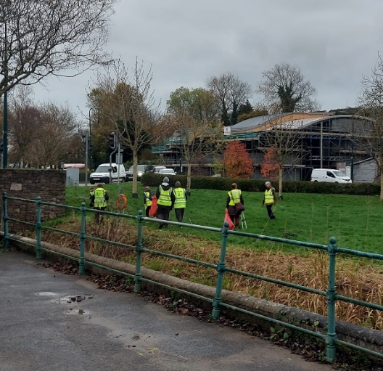

By becoming involved in the GI infrastructure project we have become less resilient in grass mowing by the planting of wildflower beds around the Castle and Millpond walks and the Commons, thus reducing our carbon emissions.

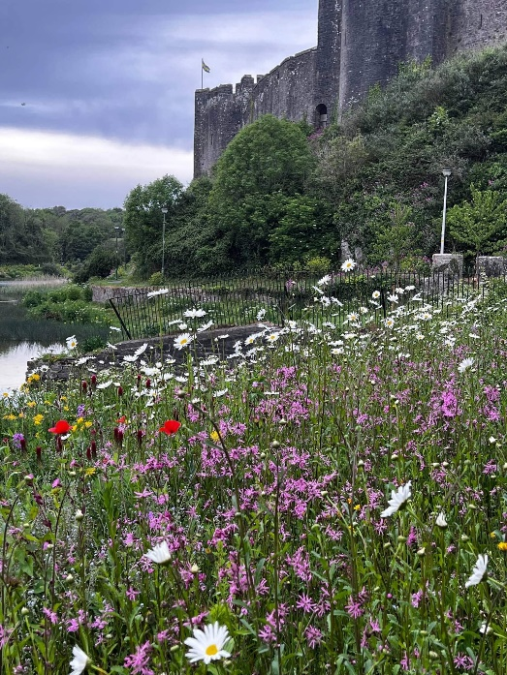

On a yearly basis, we fund and clean the Millpond removing the green algae and controlling the growth of the reeds on the banks of the pond. This helps to prevent nasty smells during periods of high temperatures and provides clearer access to the swans and ducks that frequently occupy the waters. This ensures that a better environment is created for the number of business premises located in the vicinity of the Millpond.
Also a Mill Pond Volunteer group was set up, and working closely with Mr Sid Howells, PCC and Natural Resources Wales, we have, with help from funding produced a lengthy report with regard to the quality of the water entering into the Upper and Mill Pond, as well as the Commons Stream and nearby catchment areas.

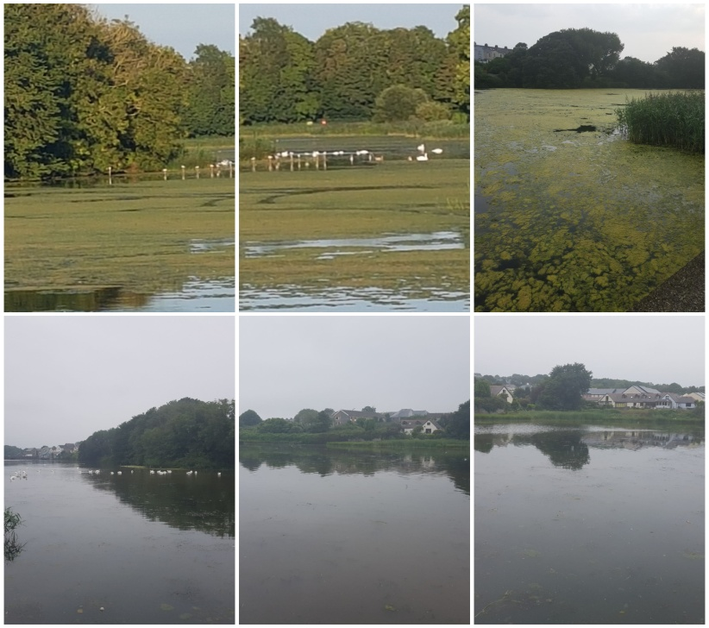

SUMMARY OF RECEIPTS AND PAYMENTS
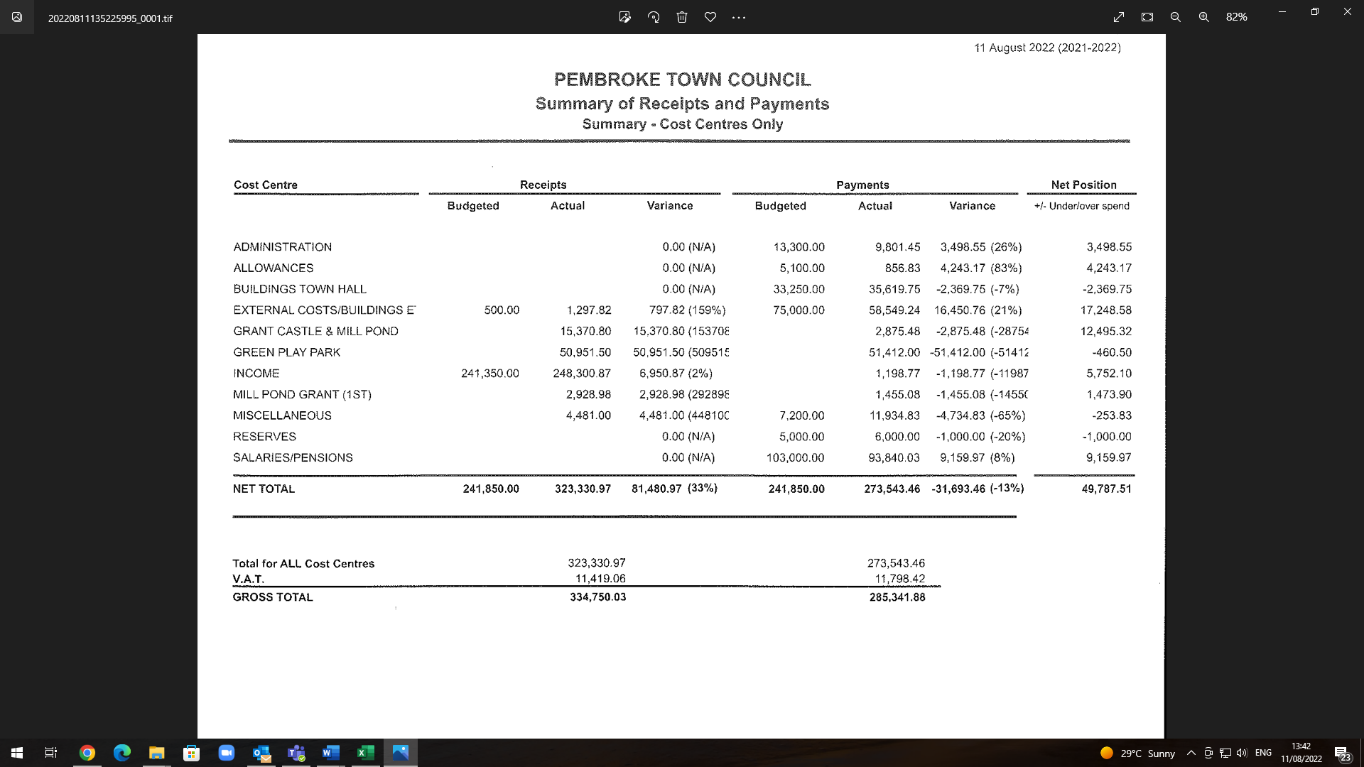

THE COVID EFFECT:
COVID -19 changed how the Council had to function and adapt to the pandemic but during 2021-2022 things gradually started to return to some normality. Employees returned to their normal duties but entry into the Town Hall was controlled to ensure maximum safety for staff and users alike.
Some community events returned such as the River Rally, the Pembroke Fair and the Santa Sleigh Run.
Some meetings continued to be held virtually but during the latter part of the period Council Meetings returned to “face to face“ meetings.

References:
Local Government and Elections (Wales) Act 2021
Wellbeing of Future Generations (Wales) Act 2015
Environment (Wales) Act 2016
Pembroke Town Council – Wellbeing and Future Generations Policy 2021
Pembroke Town Council – Standing Orders
Pembroke Town Council – Welsh Language Policy

Some pictures through the year
Installation of the William Marshal Statue

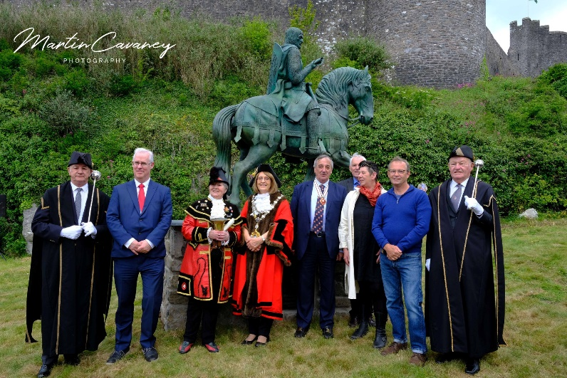

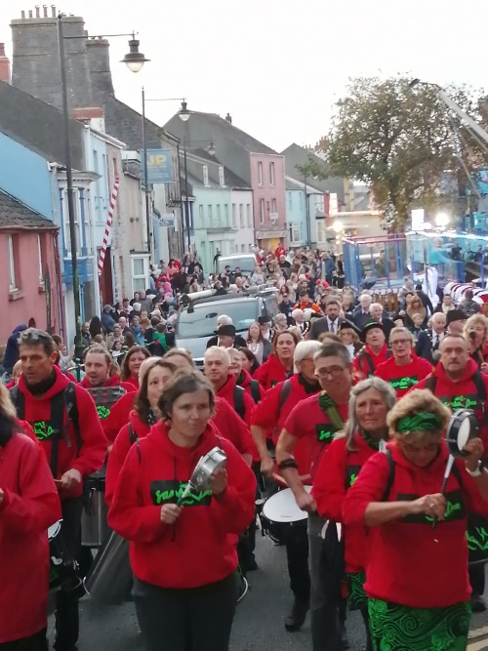
Samba Doc (Local Band) parading at the Start of Michaelmas Fair

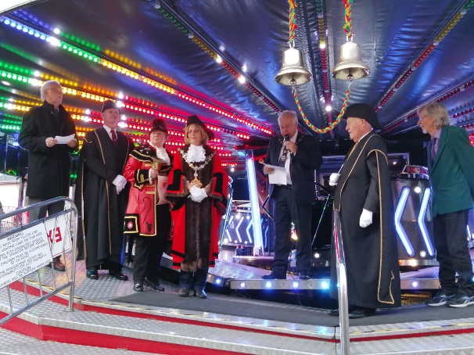

Pembroke Michaelmas Fair
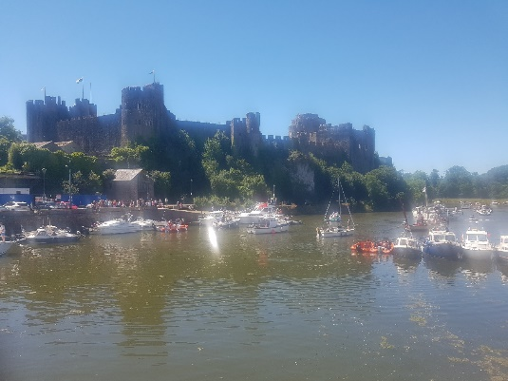

Pembroke River Rally
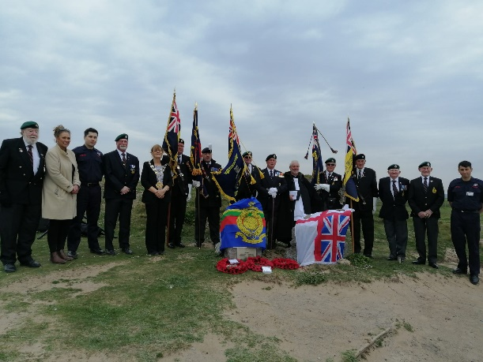
Remembering those who lost their lives in the Landing Craft Disaster at Freshwater West

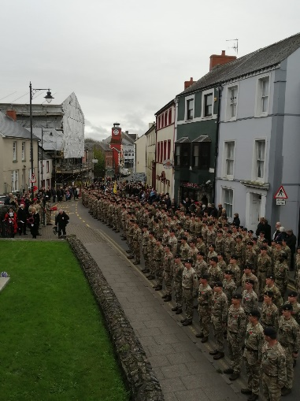

Over 200 Soldiers & local groups joining us for Remembrance Day Parade

Father Christmas visits Pembroke
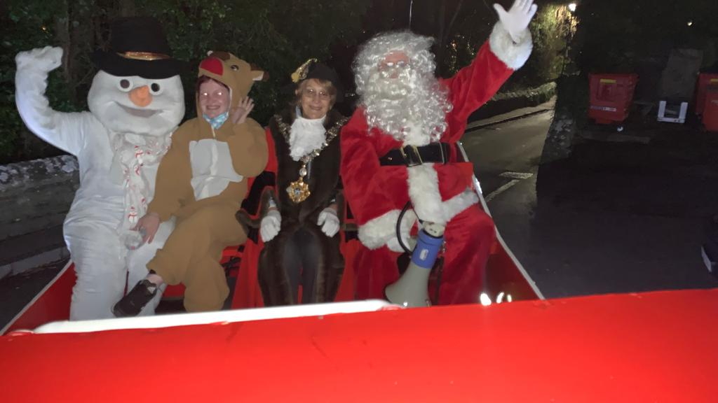

Contact
Pembroke Town Council
The Town Hall
Main Street
Pembroke
Pembrokeshire SA71 4JS
Tel: 01646 683092
Email: enquiries@pembroketowncouncil.co.uk
Website: www.pembroketownguide.org.uk

